**CO452 Programming Concepts**

**PR1 Group Project**

Game Title: METAUNIVERSE

Authors**: Name: Marius Boncica Bucks New ID: 22045429**

**Name: Martin Konecky Buck New ID: 22045464**

**GitHub Repository:** [CW2-CO452/Game1 at main · UnicoAI/CW2-CO452 (github.com)](https://github.com/UnicoAI/CW2-CO452/tree/main/Game1)

**GitHub WIKI:** [METAUNIVERSE GAME CO452 CW2 · UnicoAI/CW2-CO452 Wiki (github.com)](https://github.com/UnicoAI/CW2-CO452/wiki/METAUNIVERSE-GAME-CO452-CW2)

**Video Metauniverse Game Playing:** <https://youtu.be/RnkUMHaQTeg>

**WEB PRESENTATION**

<https://sway.office.com/b0bCY49GeHyZSwiB?ref=Link>

|  |
| --- |
| [Graphical user interface, website  Description automatically generated](https://sway.office.com/b0bCY49GeHyZSwiB?ref=email) |
| [CO452 PROGRAMMING CONCEPTS](https://sway.office.com/b0bCY49GeHyZSwiB?ref=email) |
| AUTHORS: |
| |  | | --- | | [Go to this Sway](https://sway.office.com/b0bCY49GeHyZSwiB?ref=email) | |

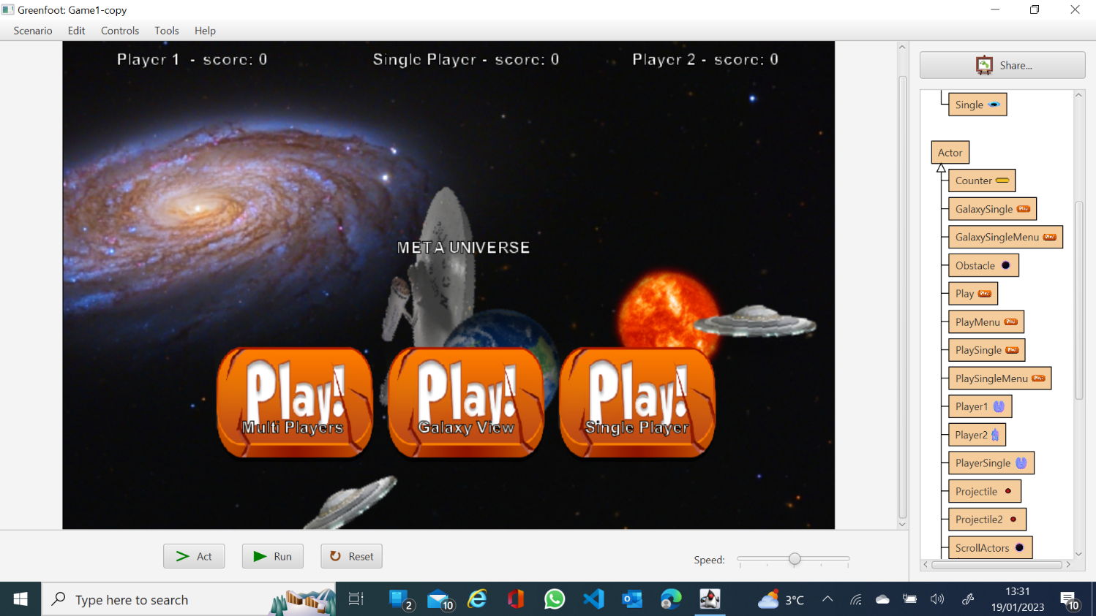

Contents

Authors**:** 1

Game Title 1

Introduction 1

Design Consideration 1

**Mapping** 1

**Structure** 1

***World Class*** 1

UML Class Diagram 1

**Actors** 1

**Players Classes** 1

**Enemies and Other Objects** 1

**Counter and Speed** 1

Development of the game and Problem Solving 1

Demonstration of Gameplay and Testing 1

**Video Metauniverse** 1

Evaluation 1

# Game Title

**METAUNIVERSE**

**Contributors: *Marius Boncica and Martin Konecky***

**PR1 Group Project – CO452 Programming Concepts**

**Video Metauniverse Game Playing Latest Version**

<https://youtu.be/RnkUMHaQTeg>

# Introduction

**METAUNIVERSE** Game is about protecting the earth from the aliens and approaching steroids.

It is a 2D green foot game, but we animated the objects to approach a 3D visual aspect.

Game contains three levels:

## 1METAUNIVERSE GALAXY View:

Player will navigate space to shoot aliens.

When in touch with Sun effects are created and text alert pop up to press Spacebar.

The game is limited to 1 minute playing.

It is a good start to accommodate user for the next level use of control commands.

## 2 METAUNIVERSE Single Player:

User will need to shoot aliens and collect boosters to increase movement speed.

A certain number of points are necessary to destroy the approaching asteroid.

Animation effects starts when touching asteroid.

Text Alert will pop up if player reach enough power to destroy the asteroid.

Text Alert Actions Executed

We use Simple timer to limit the time playing to 1 minute.

## 3 METAUNIVERSE Multiplayer

User will need to shoot aliens and collect boosters to increase movement speed.

A certain number of points are necessary to destroy the approaching asteroid.

Text Alert will pop up if player reach enough power to destroy the asteroid.

Text Alert Actions Executed

We use Simple timer to limit the time playing to 1 minute.

# Design Consideration

## **Mapping**

At the start at the game, we design a map of the space and being a group project, we decide to contain all the objects created to design the map into an array and create a map using index of array to add objects on screen map.

We start collecting images and create new animations in photoshop.

We used of the import of the Gif Image class to scale the gif images and used them frame by frame.

## **Structure**

### ***World Class***

The game contains **7 Worlds classes**:

Menu class was created for start game menu and contains button (objects) that redirect on click event user to other worlds classes as:

*Galaxy Class*—contains instruction and button to redirect to WorldLevel1 Class which is a single player galaxy navigation and aliens shooting game

*Galaxy2ndLevel Class*-- contains instruction and button to redirect to Single Class which is a single player Asteroid removal target game.

*Galaxy3rdLevel Class--* contains instruction and button to redirect to World Class which is a multiplayer player Asteroid removal target game.

## UML Class Diagram

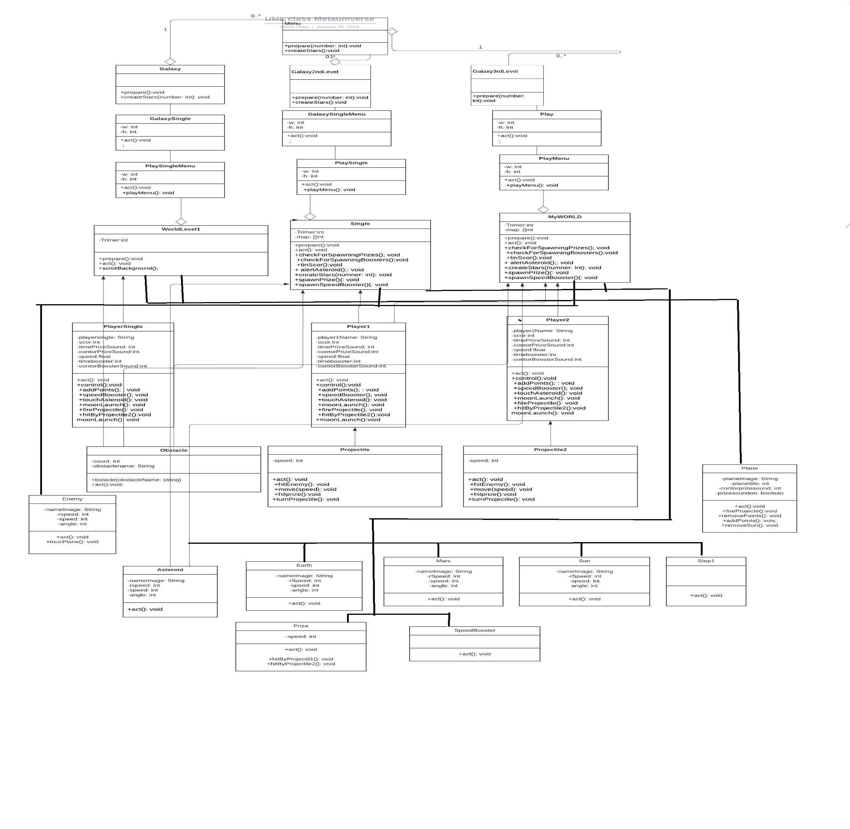

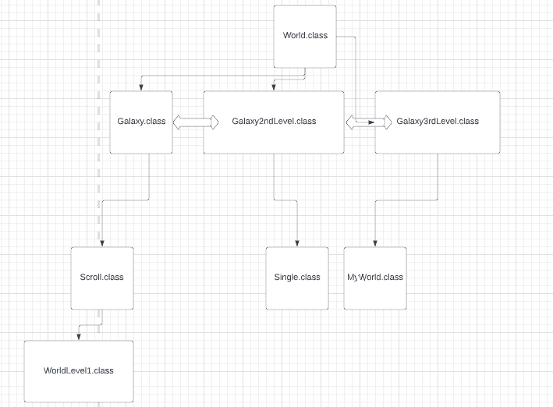

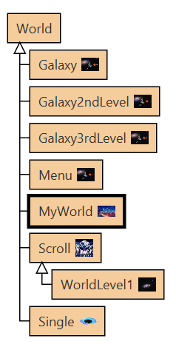

### **Actors**

After creating the map, we create the actors as players, enemies and objects floating. 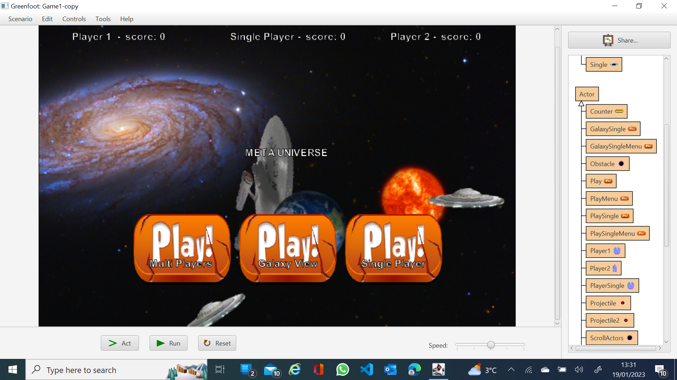

### **Players Classes**

*Player1 class*

*Player2 class*

*Player Single class*

*Plane class extends Scroll Actors class.*

All players classes contain Constructor methods to scale image, methods to shoot (by creating objects on click event or key pressed event), removal of other objects if are touching and methods to increase/ decrease score if are touching specific objects. 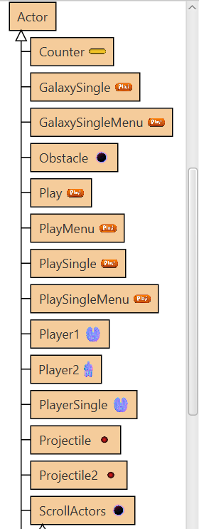

### **Enemies and Other Objects**

Enemy class – contains methods to remove object if is touching instances of projectile. Class or if are touching player. Class

Projectile classes that contain methods to remove at edge or when touching enemies.

Sun, Earth, Asteroid, Step1 classes are created to populate the map and touching behaviours with player classes or projectile classes are inserted

Prize, speed Booster classes were created to give opportunity to the player to collect points or to increase speed if are touching or shooting them.

### **Counter and Speed**

We use counter class to keep record of the points earn and we create text speed record menu for each player.

They are updating using methods described in players classes.

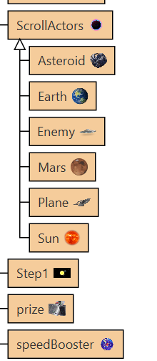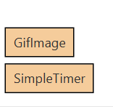

# Development of the game and Problem Solving

During the development and evaluating the game processes we encounter some issues with the Gif Images creating a java heap memory space error.

Problem was solved by using PNG images and create a method to turn and rotate and speed the image and achieve the look alike 3D model.

We add extra functionality to the menu by creating additional classes for each level that will inform user about instructions and control keys.

# Demonstration of Gameplay and Testing

## **Video Metauniverse**

We record our screen while playing all three levels of the game and the demonstration can be viewed at this link:

**Video Metauniverse Game Playing:**

<https://screencast-o-matic.com/watch/c0Vq2kVwKKW>

**Video METAUNIVERSE Game Playing Version 2 (Latest Version):**

<https://youtu.be/RnkUMHaQTeg>

We took screenshots of the game to demonstrate that the gamed passed the testing and is fully functional.

**Menu Enter World**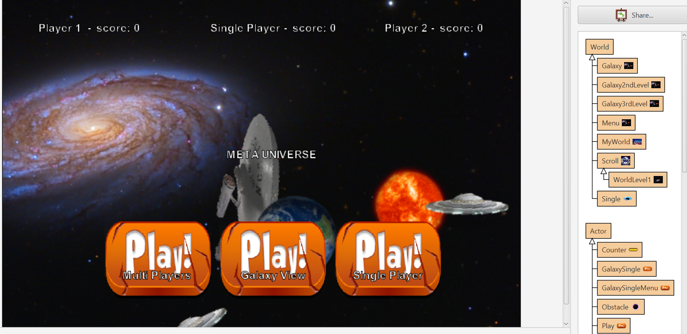

**Galaxy view intro**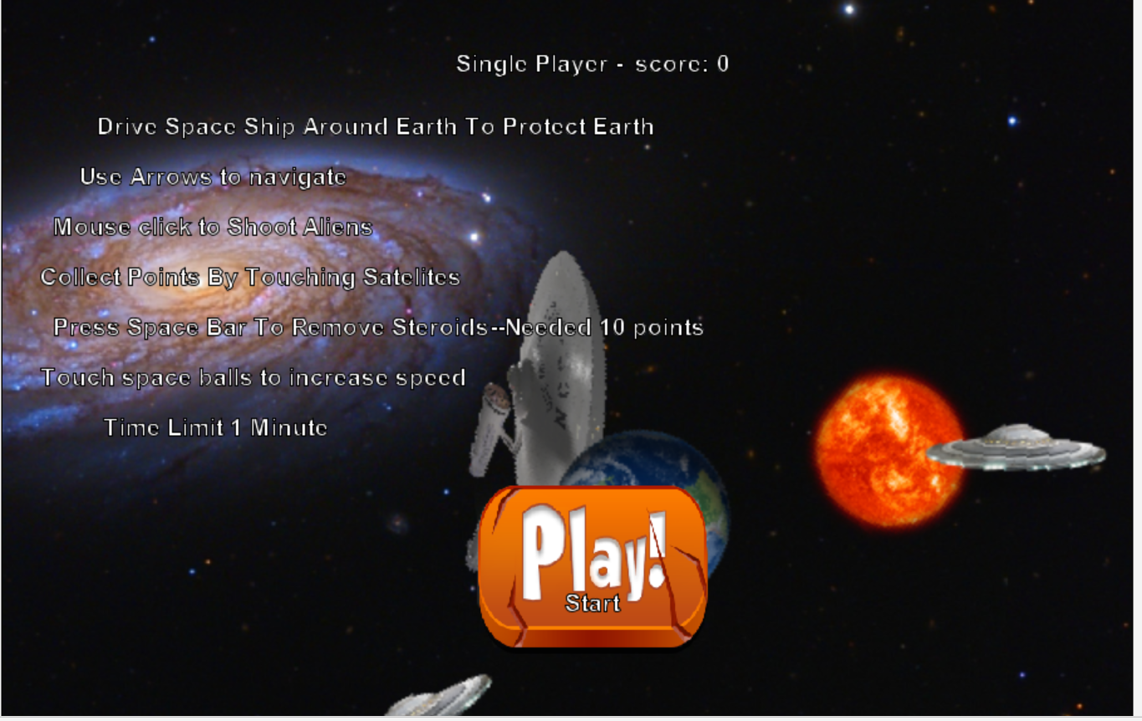

**Play**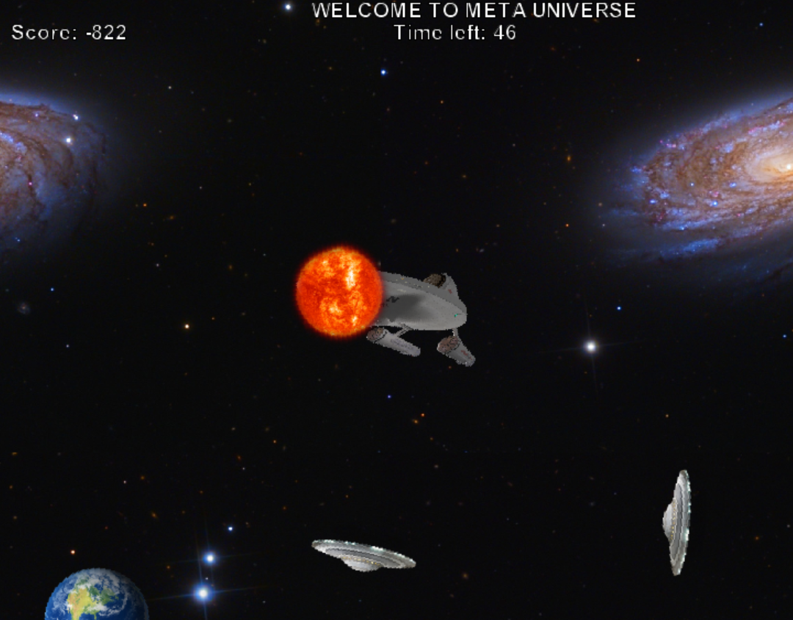

**Alert**

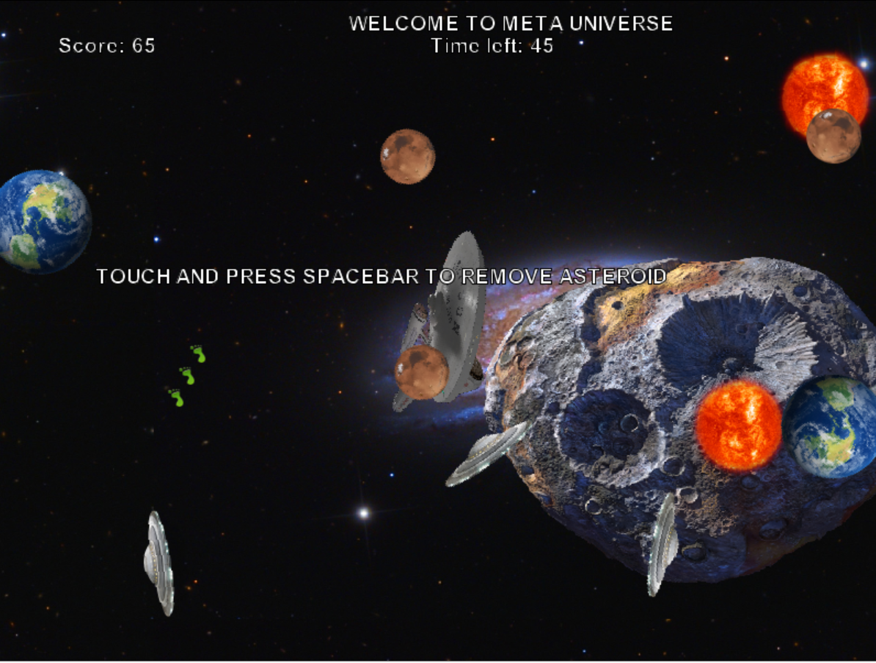

**Remove Asteroid**

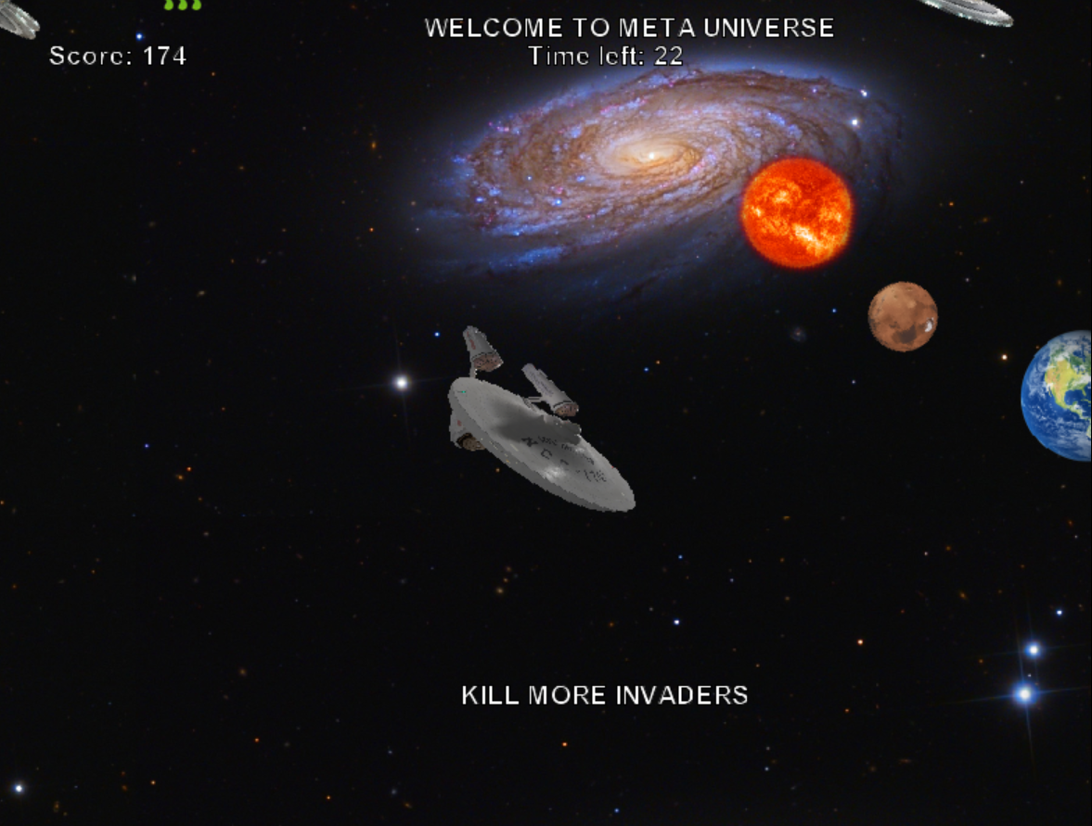

**Single Player Intro**

**Play**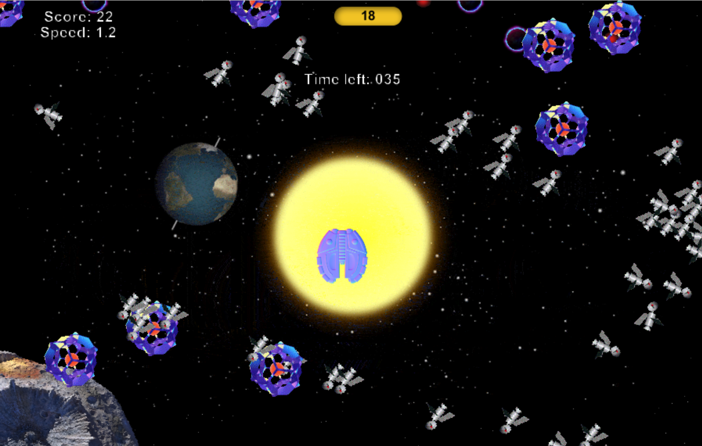

**Alert Instructions**

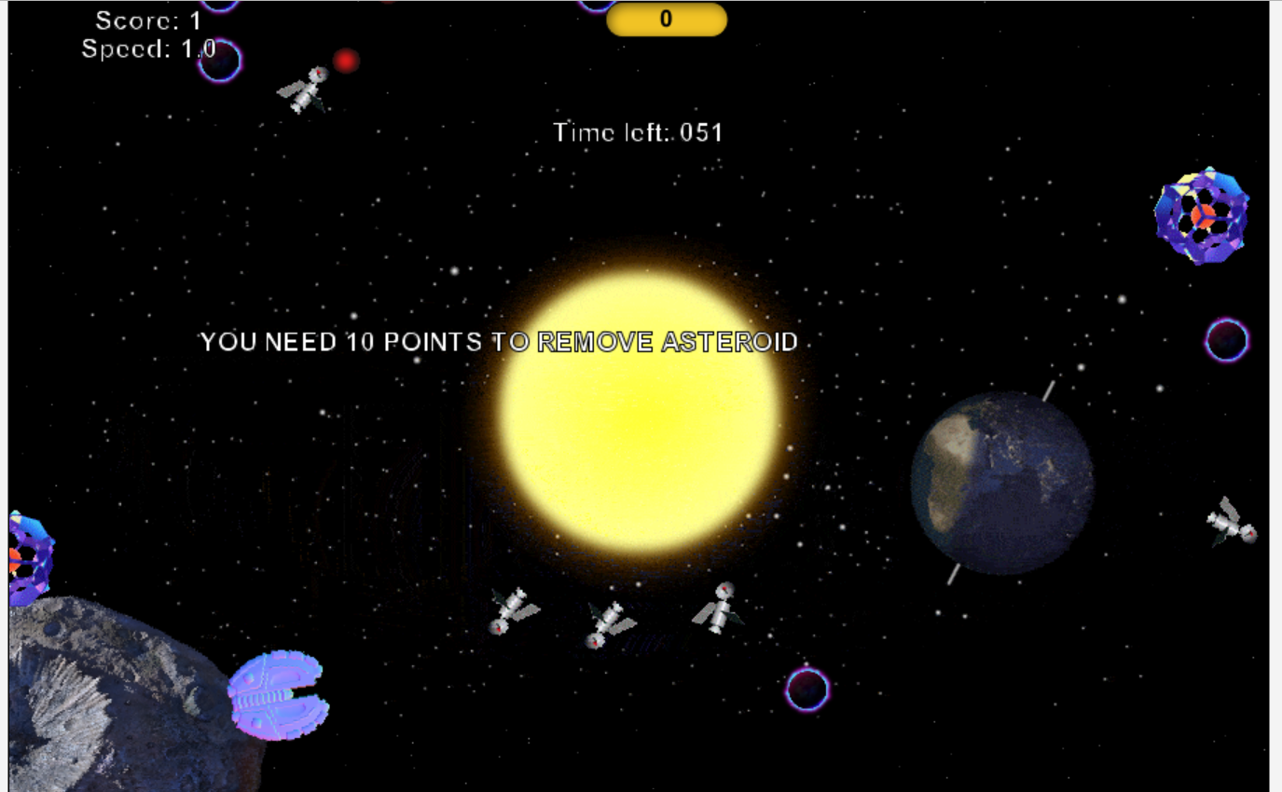

**Removing Asteroid**

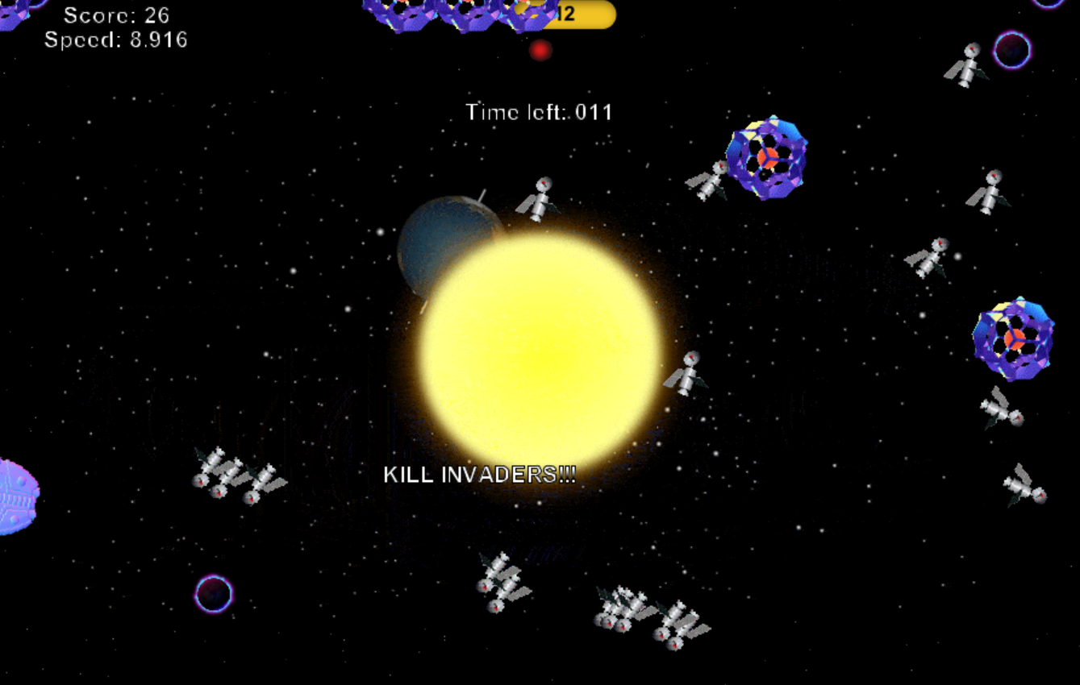

**Multiplayer Intro**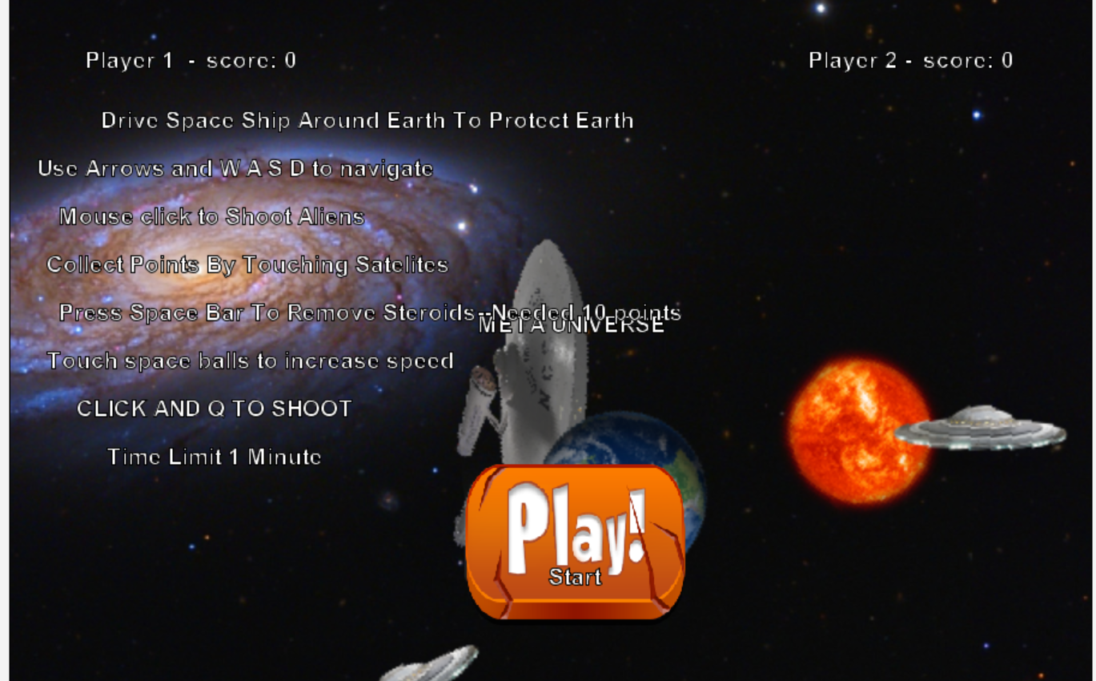

**Play**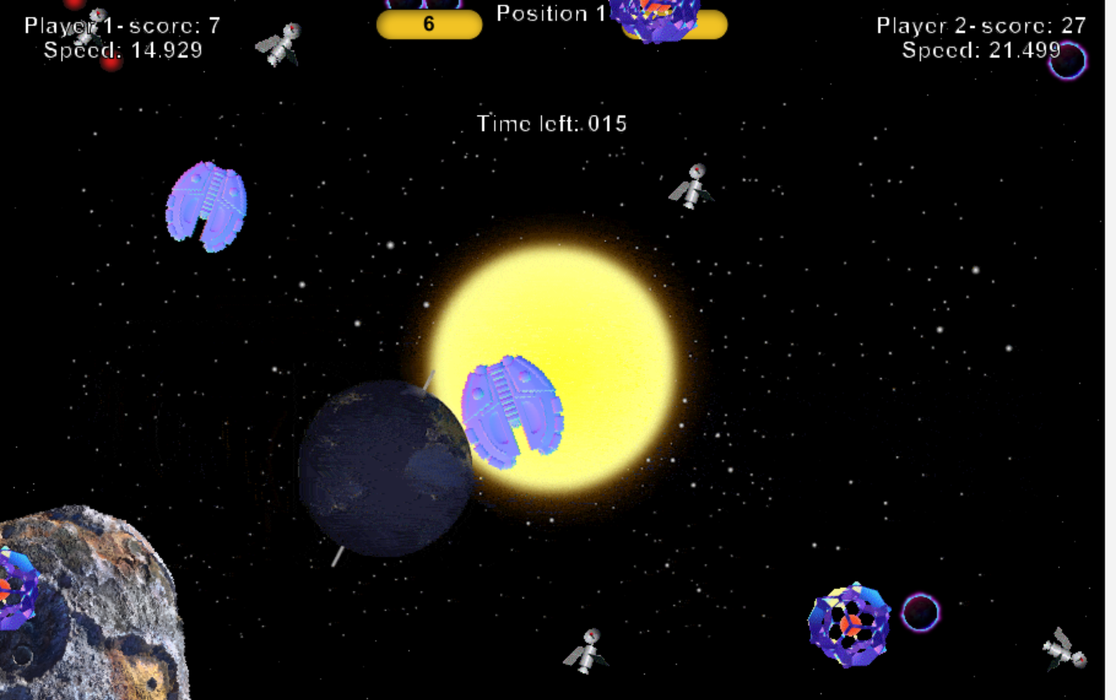

**Alert Instructions**

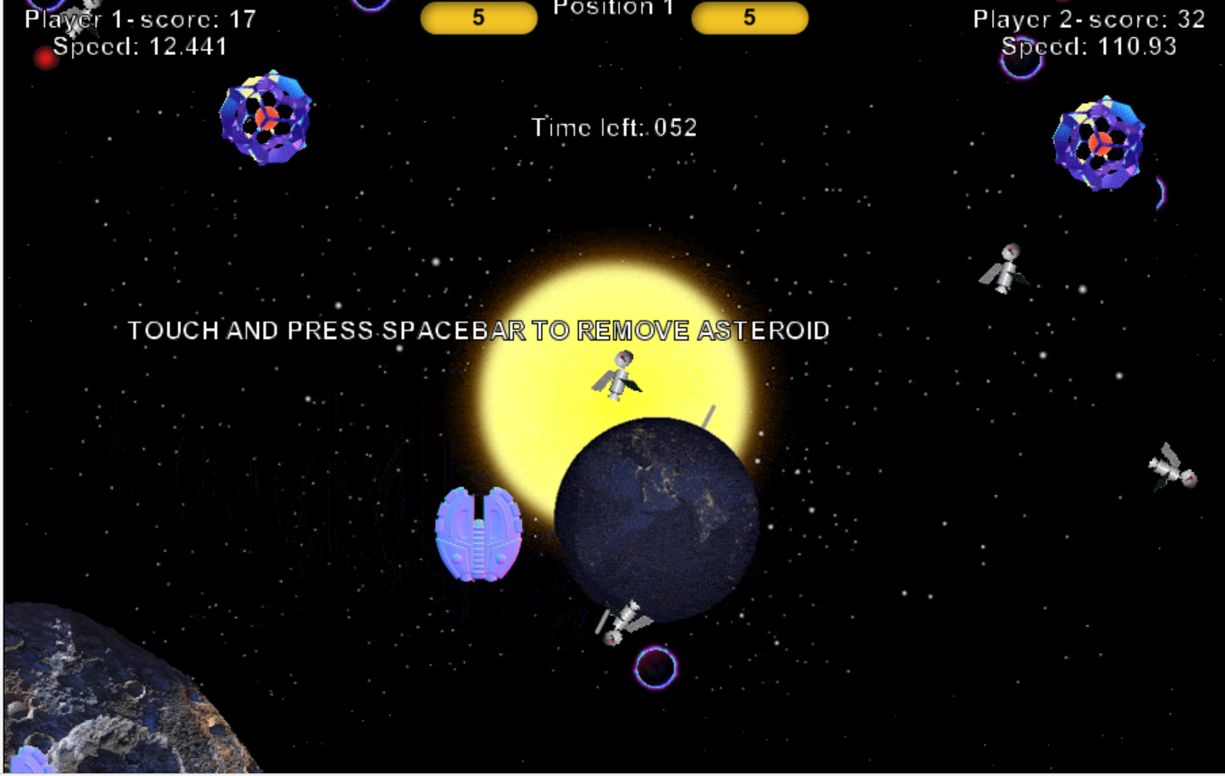

**Space Bar Instructions alert**

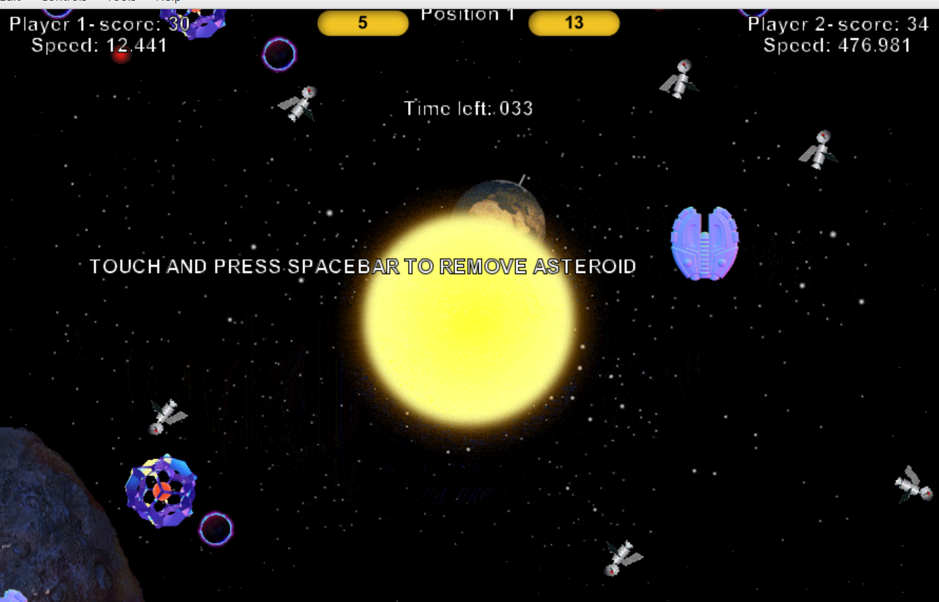

**Removing Asteroid**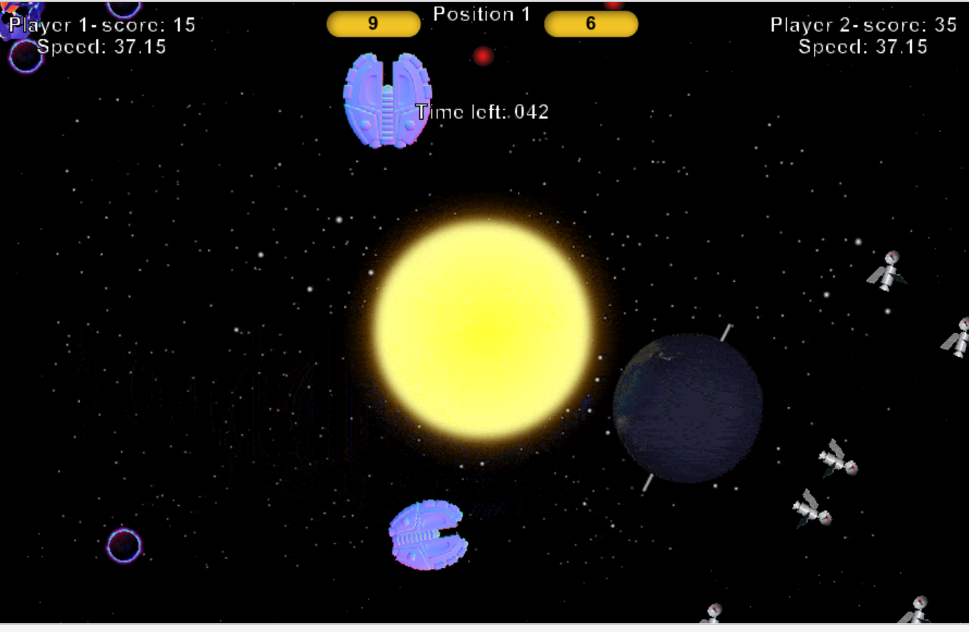

# Evaluation

The **Metauniverse** Game project was a challenging task because we had to develop the game for the first time using green foot and to create a game that respect all members ideas.

It was challenging but we both enjoyed the journey to the end of it even if involved a lot of research about Green foot and learning how to use java and use pre made green foot methods inside our classes.

More likely there are thinks that we can improve but that will need us to gain more experience coding in green foot and discover different methods and effects that we can create by spending more time on testing code variables.

# Source Code

# Galaxy.class

import greenfoot.*; // (World, Actor, GreenfootImage, Greenfoot and MouseInfo)

/**

* Metauniverse Game level 1 description intro

*

* @author (Marius Boncica)

* @version (version2 10/01/2022)

*/

public class Galaxy extends World

{

/**

* Constructor for objects of class Quit.

*

*/

public Galaxy()

{

// Create a new world with 900x600 cells with a cell size of 1x1 pixels.

super(900,600,1);

//add button to forward on WorlLevel1 when clicked

GalaxySingle button2 = new GalaxySingle();

addObject(button2,470,450); //set position bottom for button

//arrange text display on screen

showText("Single Player - score: " + PlayerSingle.scor, 470, 50);

showText("Drive Space Ship in the Universe To Find Earth like Planet ", 300, 100);

showText("Use Arrows to navigate ", 170, 140);

showText("Mouse click to Shoot Aliens ", 170, 180);

showText("Avoid Touching Sun or Aliens ", 170,220);

showText("Time Limit 1 Minute", 170, 260);

showText("Galaxy View", 470, 480);

}

//set background black and add starts created with creatStars method

public void prepare(){

GreenfootImage bkg = getBackground();

bkg.setColor(Color.BLACK);

bkg.fill();

createStars(300);

}

//create method for stars

private void createStars(int number)

{

GreenfootImage background = getBackground();

for (int i=0; i < number; i++)

{ //declare variables used for X Y position

int x = Greenfoot.getRandomNumber( getWidth() );

int y = Greenfoot.getRandomNumber( getHeight() );

int color = 150 - Greenfoot.getRandomNumber(120);

//set position

background.setColorAt(x, y, new Color(color,color,color));

}

}

}

# Galaxy2ndLevel.class

import greenfoot.*; // (World, Actor, GreenfootImage, Greenfoot and MouseInfo)

/**

* Metauniverse Game level 2 description intro

*

* @author (Marius Boncica)

* @version (version2 10/01/2022)

*/

public class Galaxy2ndLevel extends World

{

/**

* Constructor for objects of class Quit.

*

*/

public Galaxy2ndLevel()

{

// Create a new world with 900x600 cells with a cell size of 1x1 pixels.

super(900,600,1);

//add button to forward on Galaxy2ndLevel when clicked

PlaySingle button = new PlaySingle();

addObject(button,470,450);

//arrange text display on screen

showText("Single Player - score: " + PlayerSingle.scor, 470, 50);

showText("Drive Space Ship Around Earth To Protect Earth ", 300, 100);

showText("Use Arrows to navigate ", 170, 140);

showText("Mouse click to Shoot Aliens ", 170, 180);

showText("Collect Points By Touching Satelites ", 200,220);

showText("Press Space Bar To Remove Steroids--Needed 10 points", 300, 260);

showText("Touch space balls to increase speed", 200, 300);

showText("Time Limit 1 Minute", 170, 340);

showText("Start", 470, 480);

}

//set background black and add starts created with creatStars method

public void prepare(){

GreenfootImage bkg = getBackground();

bkg.setColor(Color.BLACK);

bkg.fill();

createStars(300);

}

//create method for stars

private void createStars(int number)

{

GreenfootImage background = getBackground();

for (int i=0; i < number; i++)

{

int x = Greenfoot.getRandomNumber( getWidth() );

int y = Greenfoot.getRandomNumber( getHeight() );

int color = 150 - Greenfoot.getRandomNumber(120);

background.setColorAt(x, y, new Color(color,color,color));

}

}

}

# Galaxy3rdLevel.class

/**

* Metauniverse Game level 3 description intro

*

* @author (Marius Boncica)

* @version (version2 10/01/2022)

*/

public class Galaxy3rdLevel extends World

{

/**

* Constructor for objects of class Quit.

*

*/

public Galaxy3rdLevel()

{

// Create a new world with 900x600 cells with a cell size of 1x1 pixels.

super(900,600,1);

//add button to forward on Galaxy3rdLevel when clicked

Play button = new Play();

addObject(button,470,450);

//add text to screen and define position X AND Y

showText("Player 1 - score: " + Player1.scor, 150, 50);

showText("Player 2 - score: " + Player2.scor, 750, 50);

showText("META UNIVERSE ", 470, 270);

showText("Drive Space Ship Around Earth To Protect Earth ", 300, 100);

showText("Use Arrows and W A S D to navigate ", 190, 140);

showText("Mouse click to Shoot Aliens ", 170, 180);

showText("Collect Points By Touching Satelites ", 200,220);

showText("Press Space Bar To Remove Steroids--Needed 10 points", 300, 260);

showText("Touch space balls to increase speed", 200, 300);

showText("CLICK AND Q TO SHOOT", 170, 340);

showText("Time Limit 1 Minute", 170, 380);

showText("Start", 470, 480);

}

//set background black and add starts created with creatStars method

public void prepare(){

GreenfootImage bkg = getBackground();

bkg.setColor(Color.BLACK);

bkg.fill();

createStars(300);

}

//create method for stars

private void createStars(int number)

{

GreenfootImage background = getBackground();

for (int i=0; i < number; i++)

{

int x = Greenfoot.getRandomNumber( getWidth() );

int y = Greenfoot.getRandomNumber( getHeight() );

int color = 150 - Greenfoot.getRandomNumber(120);

background.setColorAt(x, y, new Color(color,color,color));

}

}

}

# Menu.class

import greenfoot.*; // (World, Actor, GreenfootImage, Greenfoot and MouseInfo)

/**

* Menu start class of METAUNIVERSE GAME

*

* @author (Marius Boncica)

* @version (version2 10/01/2022)

*/

public class Menu extends World

{

/**

* Constructor for objects of class Quit.

*

*/

public Menu()

{

// Create a new world with 900x600 cells with a cell size of 1x1 pixels.

super(900,600,1);

//add buttons to forward on click on the game level selected

PlayMenu button = new PlayMenu();

addObject(button,270,450);

PlaySingleMenu button1 = new PlaySingleMenu();

addObject(button1,670,450);

GalaxySingleMenu button2 = new GalaxySingleMenu();

addObject(button2,470,450);

//show text and positioning on screen

showText("Player 1 - score: " + Player1.scor, 150, 50);

showText("Player 2 - score: " + Player2.scor, 750, 50);

showText("Single Player - score: " + PlayerSingle.scor, 470, 50);

showText("META UNIVERSE ", 470, 270);

showText("Multi Players ", 270, 480);

showText("Single Player", 670, 480);

showText("Galaxy View", 470, 480);

}

//set the background

public void prepare(){

GreenfootImage bkg = getBackground();

bkg.setColor(Color.BLACK);

bkg.fill();

createStars(300);

}

//method to create stars

private void createStars(int number)

{

GreenfootImage background = getBackground();

for (int i=0; i < number; i++)

{

int x = Greenfoot.getRandomNumber( getWidth() );

int y = Greenfoot.getRandomNumber( getHeight() );

int color = 150 - Greenfoot.getRandomNumber(120);

background.setColorAt(x, y, new Color(color,color,color));

}

}

}

# Myworld.class

import java.util.Random;

/**

* *Metauniverse Multiplayer level

* Author Marius Daniel Boncica

* updated 14/12/2022

*/

/**

*

*

*/

public class MyWorld extends World

{

//create Counter objects for player1 life and player 2 life counters

public static Counter player1Life = new Counter();

public static Counter player2Life = new Counter();

//declare int timer and fix value for 1 minute

private int timer = 1*60*55; //about 1 min at normal speed

//initiat mao and create table to arrange objects od specified positions

int[][] map= {

{1,1,1,3,1,1,6,1,1,1,1,1,1,1,1,2},

{1,1,1,3,6,1,1,1,1,1,1,1,1,1,1,1,1,1},

{1,1,1,1,1,1,1,1,1,1,1,1,1,1,1,1},

{1,1,1,6,1,1,1,1,1,1,1,1,1,1,1,1},

{1,1,1,1,1,1,1,1,1,1,1,1,1,1,1,1},

{1,2,1,1,1,1,1,1,1,1,1,1,1,1,1,1},

{1,1,1,1,1,1,1,1,1,0,1,1,1,1,1,1},

{1,1,1,1,1,1,1,1,1,1,1,1,1,1,1,1},

{1,1,1,1,1,1,1,1,1,1,1,1,1,1,1,1},

{1,1,1,1,1,1,1,1,1,1,1,1,1,1,1,1},

{1,1,1,1,1,1,1,1,1,6,1,1,1,1,1,1},

{1,1,1,1,1,1,1,1,1,1,1,1,1,1,1,1},

{5,2,1,1,1,1,1,1,1,1,1,1,1,1,1,1},

{1,1,1,1,1,1,1,1,1,1,1,1,1,1,1,1},

{1,1,1,1,1,1,1,1,1,1,1,1,1,1,1,1},

{1,1,1,1,1,1,1,1,1,1,1,1,1,1,1,1}

};

//create object random

Random randgen = new Random();

//declare container, timer , Booster

public static int the_width = 900, the_height = 600, cell_size = 1;

int cadran = 1, cadranTimerCounter = 1, cadranTimer = 250, spawnTimerCounterPrize = 0, spawnTimerPrize = 130, spawnTimerCounterBooster = 0, spawnTimerBooster = 260;

//create objects of players

Player1 alfa = new Player1("R.png");

Player2 beta = new Player2("R1.png");

//-----------------CONSTRUCTOR-------------------------

public MyWorld()

{ //define world size

super(900,600,1);

//use if function when creating objects and store objects to array

//array position will be refered in map above

for(int i = 0; i<16;i++)

for (int j =0; j<16; j++)

if (map[i][j]==0)

//create object of step1 and add it to array position 0

addObject(new Step1("sunearth.gif"),j*50,i*50);

//create object of Obstacleand add it to array position 2

else if(map[i][j] == 2)

addObject(new Obstacle("blackhole.png"),j*50,i*50);

//create object of Obstacle and add it to array position 3

else if (map[i][j] == 3)

addObject(new Obstacle("beeper.png"),j*50,i*50);

//create object of step1 and add it to array position 4

else if (map[i][j] == 4)

addObject(new Step1("sunearth.gif"),j*50,i*50);

else if (map[i][j] == 5)

addObject(new Asteroid("asteroid.png"),j*50,i*50);

else if (map[i][j] == 6){

addObject(new Obstacle("blackhole.png"),j*50,i*50);}

else if (map[i][j] == 7)

addObject(new Asteroid("asteroid.png"),j*50,i*50);

//call methods for this class object

prepare();

continuing();

addObject(player1Life, 350,20);

addObject(player2Life, 550,20);

player1Life.setValue(5);

player2Life.setValue(5);

Player1 p1 = new Player1("R.png");

addObject(p1, 350,400);

Player2 p2 = new Player2("R1.png");

addObject(p2,650,400);

}

//-------------Set background-------------------

private void prepare(){

GreenfootImage bkg = getBackground();

bkg.setColor(Color.BLACK);

bkg.fill();

createStars(300);

}

//-----------------set music--------------*/

private void continuing(){

setMusic();

tinScor();

}

//--------------------act method to display timer and score---------------*/

public void act(){

if( Greenfoot.mouseClicked(null) )

addObject(new prize(), 10 + randgen.nextInt()%(getWidth() - 10 + 1), 10 + randgen.nextInt()%(getHeight() - 10 + 1) );

checkForSpawningPrizes();

checkForSpawningBoosters();

tinScor();

alertAsteroid();

if (--timer == 0)

{

removeObjects(getObjects(null));

if(Player1.scor > Player2.scor){

showText("Player1 WON ||| Score: " + Player1.scor, 350,200);

showText("Player2 Loose ||| Score "+ Player2.scor, 440,300);}

else if(Player1.scor == Player2.scor){

showText("Player1 and Player2 WON ||| Score: " + Player1.scor, 450,300);

}

else if(Player1.scor < Player2.scor){showText("Player2 WON ||| Score " + Player2.scor, 450,200);

showText("Player1 Loose ||| Score "+ Player1.scor, 450,300);

}

//create a delay when time end

Greenfoot.delay(10);

//quit word and enter new world

Greenfoot.setWorld(new Menu());

}

}

//method to animate speed booster object

private void checkForSpawningBoosters(){

spawnTimerCounterBooster = (spawnTimerCounterBooster + 1)%spawnTimerBooster;

if( spawnTimerCounterBooster == 0){

addObject(new speedBooster(), 1 + randgen.nextInt()%900, 1 + randgen.nextInt()%600);

addObject(new speedBooster(), 10 + Greenfoot.getRandomNumber( the_width - 2*10 ), 10 + Greenfoot.getRandomNumber( the_height - 2*10 ) );

if(spawnTimerBooster == 0) spawnTimerBooster = 260; //initial value

}

}

//method to animate prize object

private void checkForSpawningPrizes(){

spawnTimerCounterPrize = (spawnTimerCounterPrize + 1)%spawnTimerPrize;

if( spawnTimerCounterPrize == 0 ){

addObject(new prize(), 1 + randgen.nextInt()%900, 1 + randgen.nextInt()%600);

addObject(new prize(), 10 + Greenfoot.getRandomNumber( the_width - 2*10 ), 10 + Greenfoot.getRandomNumber( the_height - 2*10 ) );

spawnTimerPrize -= 1; //speed points selectors

if(spawnTimerPrize == 0) spawnTimerPrize = 130;//initial value

}

}

//set music -create object and declare song, volume and loop

private void setMusic(){

GreenfootSound backgroundMusic = new GreenfootSound("nice_sp.mp3");

backgroundMusic.setVolume(15);

backgroundMusic.playLoop();

}

//method to create stars

private void createStars(int number)

{

GreenfootImage background = getBackground();

for (int i=0; i < number; i++)

{

int x = Greenfoot.getRandomNumber( getWidth() );

int y = Greenfoot.getRandomNumber( getHeight() );

int color = 150 - Greenfoot.getRandomNumber(120);

background.setColorAt(x, y, new Color(color,color,color));

}

}

//method Prize OBJECT ON CLICK EVENT

private void spawnPrize(){

if( Greenfoot.mouseClicked(null) ){

addObject(new prize(), 10 + randgen.nextInt()%(getWidth() - 10 + 1), 10 + randgen.nextInt()%(getHeight() - 10 + 1) );

}

}

//method SPEEDbOOSTER ONclick event

private void spawnSpeedBooster(){

if( Greenfoot.mouseClicked(null) ){

addObject(new speedBooster(), 30+randgen.nextInt()%(getWidth() - 60 + 1), 30 + randgen.nextInt()%(getHeight() - 60 + 1) );

}

}

//method score to display score for players

private void tinScor(){

// player1:

showText("Player 1- score: " + Player1.scor, 100, 20);

showText("Speed: " + (float)((int)(Player1.speed*1000) )/1000, 100, 40);

// player2 2:

showText("Player 2- score: " + Player2.scor, 800, 20);

showText("Speed: " + (float)((int)(Player2.speed*1000) )/1000, 800, 40);

// timer:

showText("Time left: "+ timer/(60*55) + (timer%(60*55))/55, 450, 100 );

showText("Position " + cadran, the_width/2, 10);

}

//create alert when scor>10 alert to remove asteroid

private void alertAsteroid(){

if(Player1.scor>=10 && Player2.scor>=10 ){

showText("GO TO ASTEROID AND PRESS SPACE TO REMOVE IT", 400, 200);

}

}

}

# Scroll.class

/**

* CLASS: Scroll (subclass of World)<br>

* AUTHOR: danpost (greenfoot.org username)<br>

* DATE: February 9, 2015<br>

* MODIFIED: February 10, 2015 (made grid world compatible)

* <br>

* DESCRIPTION: a support superclass for an infinite scrolling world;

* capable of horizontal, vertical or universal scrolling;

* scrolls either independent of any actor or by following an actor;

* scrolls background with or without actor relocations;

* capable of scrolling actors without scrolling the background image;

* capable of limited scrolling as access to field values are provided

* through getter methods;<br>

* <br>

* The only limitation, which may be dealt with in a later update, is that

* the scrolling background image is obtained from the world background

* set at the time the direction of scrolling is set -- however, this would

* complicate the code with more fields, checks and controls;

*/

public class Scroll extends World

{

private GreenfootImage bg; // the scrolling background image

private int scrollDirX, scrollDirY; // the scrolling directions along both axes

private int scrollSpeed; // the scrolling speed

private int scrollX, scrollY; // the current scrolled offset values

/** basic World constructor call */

public Scroll(int w, int h, int c) { super(w, h, c); }

/** basic World constructor call (2) */

public Scroll(int w, int h, int c, boolean b) { super(w, h, c, b); }

/** sets the direction for future scrolling (left, right, up, or down);

* the current world background image will be used for scrolling;

* @param dir the rotational angle for movement divided by 90 */

public void setDirection(int dir)

{

// determine scrolling directions along both axes

dir = dir%4;

scrollDirX = (1-dir)*((dir+1)%2);

scrollDirY = (2-dir)*(dir%2);

// initialize fields for background image scrolling

bg = new GreenfootImage(getBackground());

scrollX = 0;

scrollY = 0;

}

/**

* scrolls the background image using current field values

*/

public void scrollBackground()

{

// set new scroll offsets

scrollX = (scrollX-scrollDirX*scrollSpeed+getWidth())%getWidth();

scrollY = (scrollY-scrollDirY*scrollSpeed+getHeight())%getHeight();

// draw scrolling image onto background image

getBackground().drawImage

(

bg,

scrollX*getCellSize(),

scrollY*getCellSize()

);

getBackground().drawImage

(

bg,

((scrollX-getWidth())*scrollDirX*scrollDirX)*getCellSize(),

((scrollY-getHeight())*scrollDirY*scrollDirY)*getCellSize()

);

}

/** scrolls all movable actors using current field values;<br><br>

* NOTE: this method is for use in projects using the QActor class by danpost;

* if not using that class, remove this method and un-comment the other

* 'scrollActors' method */

public void scrollActors()

{

// scroll actors in world

for (Object obj : getObjects(null))

{

// see if actor is of QActor type

if (obj instanceof ScrollActors)

{

// scroll QActor object

ScrollActors actor = (ScrollActors)obj;

actor.setQLocation

(

actor.getQX()-scrollDirX*scrollSpeed*ScrollActors.QVAL,

actor.getQY()-scrollDirY*scrollSpeed*ScrollActors.QVAL

);

}

else

{

// scroll non-QActor object

Actor actor = (Actor)obj;

actor.setLocation

(

actor.getX()-scrollDirX*scrollSpeed,

actor.getY()-scrollDirY*scrollSpeed

);

}

}

}

/** scrolls all movable actors using current field values;<br><br>

* NOTE: this method is for use in projects not using the QActor class by danpost;

* if not using that class, remove the other 'scrollActors' method and un-comment

* this one */

// public void scrollActors()

// {

// // scroll actors in world

// Actor actor = (Actor)obj;

// actor.setLocation

// (

// actor.getX()-scrollDirX*scrollSpeed,

// actor.getY()-scrollDirY*scrollSpeed

// );

// }

/** scrolls the background and all movable actors using current field values */

public void scrollAll()

{

// scroll background image

scrollBackground();

// scroll actors in world

scrollActors();

}

/** scrolls the background and all movable actors using current field values so that

* the given actor is scrolled to the location coordinates given;

* @param actor the actor whose location is to be adjusted

* @param x the coordinate along the x-axis at which the actor is to be placed

* @param y the coordinate along the y-axis at which the actor is to be placed */

public void setActorAt(Actor actor, int x, int y)

{

// ensure actor is in world

if (actor.getWorld() != this) return;

// scroll all horizontally getting actor to its new x-coordinate location

setScrollSpeed(actor.getX()-x);

setDirection(0);

scrollAll();

// scroll all vertically getting actor to its new y-coodinate location

setScrollSpeed(actor.getY()-y);

setDirection(1);

scrollAll();

}

/** returns the scrolling direction along the x-axis

* ('1' for right, '0' for none and '-1' for left)

* @return direction of horizontal scrolling */

public int getDirectionX() { return scrollDirX; }

/** returns the scrolling direction along the y-axis

* ('1' for down, '0' for none and '-1' for up)

* @return direction of vertical scrolling */

public int getDirectionY() { return scrollDirY; }

/** returns the current scrolled amount along the x-axis

* @return current distance horizontally scrolled */

public int getScrollX() { return scrollX; }

/** returns the current scrolled amount along the y-axis

* @return current distance vertically scrolled */

public int getScrollY() { return scrollY; }

/** returns the current value set for the speed of scrolling

* @return the current scrolling speed */

public int getScrollSpeed() { return scrollSpeed; }

/** sets the value for the speed of future scrolling to the given value

* @param speed the value to set the speed of scrolling to */

public void setScrollSpeed(int speed) { scrollSpeed = speed; }

}

# WorldLevel1.class

/**

* MetaUniverse level Galaxy view single player

*

* @author (Marius Boncica & Martin Konecny)

* @version (version2 10/01/2022)

*/

public class WorldLevel1 extends Scroll

{//declare variables

private Actor ship; // the main actor

public static Counter planeLife = new Counter(); //counter

private int timer = 1*60*55; //time limit to 1 minute

//define constructor

public WorldLevel1()

{

super(800, 600, 1);// the background image

//image scale

GreenfootImage image = new GreenfootImage("galaxy.jpg");

image.scale(getWidth(), getHeight());

setBackground(image);

// set scrolling speed and direction

setDirection(0);

setScrollSpeed(2);

// the ship

addObject(ship = new Plane("spaces11.png"), getWidth()/8, getHeight()/8);

// add enemey object

addObject(Enemy.scoreDisp = new Actor(){}, 80, 20);

Enemy.scoreDisp.setImage(new GreenfootImage(1, 1));

Enemy.created = 0;

// the actor to display the score

addObject(Sun.scoreDisp = new Actor(){}, 40, 40);

Earth.created = 0;

Earth.unhit = 0;

// the actor to display the score

addObject(Earth.scoreDisp = new Actor(){}, 30, 60);

Mars.created = 0;

Mars.unhit = 0;

// the actor to display the score

addObject(Mars.scoreDisp = new Actor(){}, 20, 80);

}

public void act()

{

// keeps ship center screen

setActorAt(ship, getWidth()/2, getHeight()/2);

//add text on screen to customize user experience

showText("WELCOME TO META UNIVERSE ", 470, 20);

showText("Score: " + Plane.score, 100, 40);

// timer:

showText("Time left: "+ (timer%(60*55))/55, 450, 40 );

// change worlds

if ("enter".equals(Greenfoot.getKey())) {

Greenfoot.setWorld(new Menu());}

// scroll background image

scrollBackground();

// spawn alienships (with increasing frequency)

if (Greenfoot.getRandomNumber(200-Enemy.created/10) == 0)

{

int y = Greenfoot.getRandomNumber(getHeight());

addObject(new Enemy(), getWidth()+40, y);

}

if (Greenfoot.getRandomNumber(200-Sun.created/10) == 0)

{

int y = Greenfoot.getRandomNumber(getHeight());

addObject(new Sun(), getWidth()+40, y);

}

if (Greenfoot.getRandomNumber(200-Earth.created/10) == 0)

{

int y = Greenfoot.getRandomNumber(getHeight());

addObject(new Earth(), getWidth()+40, y);

}

if (Greenfoot.getRandomNumber(250-Mars.created/10) == 0)

{

int y = Greenfoot.getRandomNumber(getHeight());

addObject(new Mars(), getWidth()+40, y);

}

//function when time ends and display text according the number of points

if (--timer == 0)

{

removeObjects(getObjects(null));

Greenfoot.stop();

if(Plane.score >= 0){

showText("YOU WON ||| Score: " + Plane.score, 350,200);

}

else if(Plane.score < 0){

showText("You Loose ||| Score "+ Plane.score, 450,300);

}

//delay response

Greenfoot.delay(5);

//enter new world

Greenfoot.setWorld(new Menu());

}

}

}

# Single.class

import java.util.Random;

/**

* *Metauniverse game level 2 single player world

* Author Marius Daniel Boncica and Martin Konecny

* updated 14/12/2022

*/

public class Single extends World

{//create an object on counter class

public static Counter playerSingleLife = new Counter();

//declare int timer and fix value to 1 minute

private int timer = 1*60*55; //about 1 min at normal speed

//initiate map table made by array of objects items created

int[][] map= {

{1,1,1,3,1,1,6,1,1,1,1,1,1,1,1,2},

{1,1,1,3,6,1,1,1,1,1,1,1,1,1,1,1,1,1},

{1,1,1,1,1,1,1,1,1,1,1,1,1,1,1,1},

{1,1,1,6,1,1,1,1,1,1,1,1,1,1,1,1},

{1,1,1,1,1,1,1,1,1,1,1,1,1,1,1,1},

{1,2,1,1,1,1,1,1,1,1,1,1,1,1,1,1},

{1,1,1,1,1,1,1,1,1,0,1,1,1,1,1,1},

{1,1,1,1,1,1,1,1,1,1,1,1,1,1,1,1},

{1,1,1,1,1,1,1,1,1,1,1,1,1,1,1,1},

{1,1,1,1,1,1,1,1,1,1,1,1,1,1,1,1},

{1,1,1,1,1,1,1,1,1,6,1,1,1,1,1,1},

{1,1,1,1,1,1,1,1,1,1,1,1,1,1,1,1},

{5,2,1,1,1,1,1,1,1,1,1,1,1,1,1,1},

{1,1,1,1,1,1,1,1,1,1,1,1,1,1,1,1},

{1,1,1,1,1,1,1,1,1,1,1,1,1,1,1,1},

{1,1,1,1,1,1,1,1,1,1,1,1,1,1,1,1}

};

//declare variables as timer, counter, points, booster, spees

Random randgen = new Random();

public static int the_width = 900, the_height = 600, cell_size = 1;

int spawnTimerCounterPrize = 0, spawnTimerPrize = 130, spawnTimerCounterBooster = 0, spawnTimerBooster = 260;

//create an object of class PlayerSingle

PlayerSingle alfa = new PlayerSingle("R1.png");

//-----------------CONSTRUCTOR-------------------------

public Single()

{

super(900,600,1);

for(int i = 0; i<16;i++)

for (int j =0; j<16; j++)

//create an array of objects and allocate objects to specific location

//use array index to position on map above

if (map[i][j]==0)

addObject(new Step1("sunearth.gif"),j*50,i*50);

else if(map[i][j] == 2)

addObject(new Obstacle("blackhole.png"),j*50,i*50);

else if (map[i][j] == 3)

addObject(new Obstacle("beeper.png"),j*50,i*50);

else if (map[i][j] == 4)

addObject(new Step1("sunearth.gif"),j*50,i*50);

else if (map[i][j] == 5)

addObject(new Asteroid("asteroid.png"),j*50,i*50);

else if (map[i][j] == 6){

addObject(new Obstacle("blackhole.png"),j*50,i*50);}

else if (map[i][j] == 7)

addObject(new Asteroid("asteroid.png"),j*50,i*50);

//call methods for this class

prepare();

continuing();

addObject(new PlayerSingle("R1.png"),450,450);

addObject(playerSingleLife, 470,20);

playerSingleLife.setValue(0);

}

//-------------Set Background-------------------

private void prepare(){

GreenfootImage bkg = getBackground();

bkg.setColor(Color.BLACK);

bkg.fill();

createStars(300);

}

//-----------------set music--------------*/

private void continuing(){

setMusic();

tinScor();

}

//--------------------method act ---------------*/

public void act(){

if( Greenfoot.mouseClicked(null) )

addObject(new prize(), 10 + randgen.nextInt()%(getWidth() - 10 + 1), 10 + randgen.nextInt()%(getHeight() - 10 + 1) );

//call bolean function

checkForSpawningPrizes();

checkForSpawningBoosters();

//display score

tinScor();

//ALERT REMOVE ASTEROID

alertAsteroid();

//completion text to show on screen related to score value

if (--timer == 0)

{

removeObjects(getObjects(null));

if(Player1.scor > 0 ){

showText("YOU WON ||| Score: " + PlayerSingle.scor, 350,200);

}

else if(Player1.scor == 0){

showText("Try Again " + PlayerSingle.scor, 450,300);

}

Greenfoot.delay(10);

//delay next step

Greenfoot.setWorld(new Menu());

//quit world

}

}

//booster method animation

private void checkForSpawningBoosters(){

spawnTimerCounterBooster = (spawnTimerCounterBooster + 1)%spawnTimerBooster;

if( spawnTimerCounterBooster == 0){

addObject(new speedBooster(), 1 + randgen.nextInt()%900, 1 + randgen.nextInt()%600);

addObject(new speedBooster(), 10 + Greenfoot.getRandomNumber( the_width - 2*10 ), 10 + Greenfoot.getRandomNumber( the_height - 2*10 ) );

if(spawnTimerBooster == 0) spawnTimerBooster = 260; //initial value

}

}

//prize objects method animation

private void checkForSpawningPrizes(){

spawnTimerCounterPrize = (spawnTimerCounterPrize + 1)%spawnTimerPrize;

if( spawnTimerCounterPrize == 0 ){

addObject(new prize(), 1 + randgen.nextInt()%900, 1 + randgen.nextInt()%600);

addObject(new prize(), 10 + Greenfoot.getRandomNumber( the_width - 2*10 ), 10 + Greenfoot.getRandomNumber( the_height - 2*10 ) );

spawnTimerPrize -= 1; //speed points selectors

if(spawnTimerPrize == 0) spawnTimerPrize = 130;//initial value

}

}

private void setMusic(){

/*

* set music

* Skrillex - Scary Monsters And Nice Sprites

*/

GreenfootSound backgroundMusic = new GreenfootSound("nice_sp.mp3");

backgroundMusic.setVolume(15);

backgroundMusic.playLoop();

}

//method to create stars

private void createStars(int number)

{

GreenfootImage background = getBackground();

for (int i=0; i < number; i++)

{

int x = Greenfoot.getRandomNumber( getWidth() );

int y = Greenfoot.getRandomNumber( getHeight() );

int color = 150 - Greenfoot.getRandomNumber(120);

background.setColorAt(x, y, new Color(color,color,color));

}

}

/** method prize object on click event */

private void spawnPrize(){

if( Greenfoot.mouseClicked(null) ){

addObject(new prize(), 10 + randgen.nextInt()%(getWidth() - 10 + 1), 10 + randgen.nextInt()%(getHeight() - 10 + 1) );

}

}

/** method spedBooster object on click event */

private void spawnSpeedBooster(){

if( Greenfoot.mouseClicked(null) ){

addObject(new speedBooster(), 30+randgen.nextInt()%(getWidth() - 60 + 1), 30 + randgen.nextInt()%(getHeight() - 60 + 1) );

}

}

//add text with score and speed to be displayed on screen

private void tinScor(){

// player1:

showText("Score: " + PlayerSingle.scor, 100, 20);

showText("Speed: " + (float)((int)(PlayerSingle.speed*1000) )/1000, 100, 40);

// timer:

showText("Time left: "+ timer/(60*55) + (timer%(60*55))/55, 450, 100 );

}

//create alert when scor>10 alert to remove asteroid

private void alertAsteroid(){

if(PlayerSingle.scor>=10 ){

showText("GO TO ASTEROID AND PRESS SPACE TO REMOVE IT", 400, 200);

}

}

}

# Counter.class

import greenfoot.*; // (World, Actor, GreenfootImage, Greenfoot and MouseInfo)

/**

* A Counter class that allows you to display a numerical value on screen.

*

* The Counter is an actor, so you will need to create it, and then add it to

* the world in Greenfoot. If you keep a reference to the Counter then you

* can adjust its value. Here's an example of a world class that

* displays a counter with the number of act cycles that have occurred:

*

* <pre>

* class CountingWorld

* {

* private Counter actCounter;

*

* public CountingWorld()

* {

* super(600, 400, 1);

* actCounter = new Counter("Act Cycles: ");

* addObject(actCounter, 100, 100);

* }

*

* public void act()

* {

* actCounter.setValue(actCounter.getValue() + 1);

* }

* }

* </pre>

*

* @updates made by Marius Boncica

* @version 3.0

*/

public class Counter extends Actor

{

private static final Color transparent = new Color(0,0,0,0);

private GreenfootImage background;

private int value;

private int target;

private String prefix;

public Counter()

{

this(new String());

}

/**

* Create a new counter, initialised to 0.

*/

public Counter(String prefix)

{

background = getImage(); // get image from class

value = 0;

target = 0;

this.prefix = prefix;

updateImage();

}

/**

* Animate the display to count up (or down) to the current target value.

*/

public void act()

{

if (value < target) {

value++;

updateImage();

}

else if (value > target) {

value--;

updateImage();

}

}

/**

* Add a new score to the current counter value. This will animate

* the counter over consecutive frames until it reaches the new value.

*/

public void add(int score)

{

target += score;

}

/**

* Return the current counter value.

*/

public int getValue()

{

return target;

}

/**

* Set a new counter value. This will not animate the counter.

*/

public void setValue(int newValue)

{

target = newValue;

value = newValue;

updateImage();

}

/**

* Sets a text prefix that should be displayed before

* the counter value (e.g. "Score: ").

*/

public void setPrefix(String prefix)

{

this.prefix = prefix;

updateImage();

}

/**

* Update the image on screen to show the current value.

*/

private void updateImage()

{

GreenfootImage image = new GreenfootImage(background);

GreenfootImage text = new GreenfootImage(prefix + value, 22, Color.BLACK, transparent);

if (text.getWidth() > image.getWidth() - 20)

{

image.scale(text.getWidth() + 20, image.getHeight());

}

image.drawImage(text, (image.getWidth()-text.getWidth())/2,

(image.getHeight()-text.getHeight())/2);

setImage(image);

}

}

# GalaxySingle.class

/**

* Game Cw2

*

* @Marius Boncica & Martin Konecny

* @version 12

*/

public class GalaxySingle extends Actor

{ GreenfootImage myGif = new GreenfootImage("Play1.png");

/**

* create an object og gif image

* Constructor class-adjust Height and width

*/

public GalaxySingle(){

GreenfootImage myGif = getImage();

int h = (int)myGif.getHeight()/1;

int w = (int)myGif.getWidth()/2;

myGif.scale(h,w);

}

// act method to describe animarion behaviour of class when clicked

public void act()

{if(Greenfoot.mousePressed(this))

{getImage().scale((int)Math.round(getImage().getWidth()*0.9),

(int)Math.round(getImage().getHeight()*0.9));

}

// Add your action code here.

if(Greenfoot.mouseClicked(this))

{ Greenfoot.delay(5);

Greenfoot.setWorld(new WorldLevel1());

}

}

}

# GalaxySingleMenu.class

/**

* Game Cw2

*

* @Marius Boncica & Martin Konecny

* @version 12

*/

public class GalaxySingleMenu extends Actor

//create object of gif image

{ GreenfootImage myGif = new GreenfootImage("Play1.png");

/**

* Constructor

* scale image

*/

public GalaxySingleMenu(){

GreenfootImage myGif = getImage();

int h = (int)myGif.getHeight()/1;

int w = (int)myGif.getWidth()/2;

myGif.scale(h,w);

}

//method to animate behaviour on click event

public void act()

{if(Greenfoot.mousePressed(this))

{getImage().scale((int)Math.round(getImage().getWidth()*0.9),

(int)Math.round(getImage().getHeight()*0.9));

}

// Add your action code here.

if(Greenfoot.mouseClicked(this))

{ Greenfoot.delay(5);

//on click event enter word Galaxy

Greenfoot.setWorld(new Galaxy());

}

}

}

# Obstacle.Class

/**

* update

*

* @author Marius Boncica

* @version (1.01 8/12/2022)

*/

public class Obstacle extends Actor

{

/**

* declare variables

*/

int count;

String obstacleName;

/**

* constructor

* scale image

*/

public Obstacle(String obstacleName)

{

this.obstacleName = obstacleName;

setImage(this.obstacleName);

getImage().scale(50,50); }

//method act for class bahaviour

//set location random

public void act()

{

count++;

if(count % (Greenfoot.getRandomNumber(30) +1) == 0 && this.obstacleName != "news - Copy.gif")

{

setLocation(getX() + 30, getY() );

if(getX() == getWorld().getWidth()-1)

setLocation(1, getY());

}

}

}

# Play.class

/**

* button redirect to world MyWorld

*

* @Marius Boncica

* @3.19/01/2023

*/

public class Play extends Actor

//create object of gif

{ GreenfootImage myGif = new GreenfootImage("Play1.png");

/**

* Constructor

* scale image

*/

public Play(){

GreenfootImage myGif = getImage();

int h = (int)myGif.getHeight()/1;

int w = (int)myGif.getWidth()/2;

myGif.scale(h,w);

}

//behaviour of image on click event

public void act()

{if(Greenfoot.mousePressed(this))

{getImage().scale((int)Math.round(getImage().getWidth()*0.9),

(int)Math.round(getImage().getHeight()*0.9));

}

// Add your action code here.

if(Greenfoot.mouseClicked(this))

{ Greenfoot.delay(5);

//redirect event on click to world MyWorld

Greenfoot.setWorld(new MyWorld());

}

}

}

# Playmenu.class

/**

* Button redirect to Galaxy3rdLevel

*

* @Marius Boncica

* @version (3 19/01/2023)

*/

public class PlayMenu extends Actor

{ GreenfootImage myGif = new GreenfootImage("Play1.png");

/**

* Constructor--Scale Image

*/

public PlayMenu(){

GreenfootImage myGif = getImage();

int h = (int)myGif.getHeight()/1;

int w = (int)myGif.getWidth()/2;

myGif.scale(h,w);

}

//METHOD ACT DESCRIBE ANIMATION BEHAVIOUR OF IMAGE ON CLICK EVENT

public void act()

{if(Greenfoot.mousePressed(this))

{getImage().scale((int)Math.round(getImage().getWidth()*0.9),

(int)Math.round(getImage().getHeight()*0.9));

}

// Add your action code here.

if(Greenfoot.mouseClicked(this))

{ Greenfoot.delay(5);

//REDIRECT ON CLICK EVENT TO WORLD Galaxy3rdLevel

Greenfoot.setWorld(new Galaxy3rdLevel());

}

}

}

# PlaySingle.class

/**

* Write a description of class Play here.

*

* @author (Marius & Martin)

* @version (a version number or a date)

*/

public class PlaySingle extends Actor

{ GreenfootImage myGif = new GreenfootImage("Play1.png");

/**

* Act - do whatever the Play wants to do. This method is called whenever

* the 'Act' or 'Run' button gets pressed in the environment.

*/

public PlaySingle(){

GreenfootImage myGif = getImage();

int h = (int)myGif.getHeight()/1;

int w = (int)myGif.getWidth()/2;

myGif.scale(h,w);

}

public void act()

{if(Greenfoot.mousePressed(this))

{getImage().scale((int)Math.round(getImage().getWidth()*0.9),

(int)Math.round(getImage().getHeight()*0.9));

}

// Add your action code here.

if(Greenfoot.mouseClicked(this))

{ Greenfoot.delay(5);

Greenfoot.setWorld(new Single());

}

}

}

# PlaySingleMenu.Class

import greenfoot.*; // (World, Actor, GreenfootImage, Greenfoot and MouseInfo)

/**

* Write a description of class Play here.

*

* @author (Marius & Martin)

* @version (a version number or a date)

*/

public class PlaySingleMenu extends Actor

{ GreenfootImage myGif = new GreenfootImage("Play1.png");

/**

* Act - do whatever the Play wants to do. This method is called whenever

* the 'Act' or 'Run' button gets pressed in the environment.

*/

public PlaySingleMenu(){

GreenfootImage myGif = getImage();

int h = (int)myGif.getHeight()/1;

int w = (int)myGif.getWidth()/2;

myGif.scale(h,w);

}

public void act()

{if(Greenfoot.mousePressed(this))

{getImage().scale((int)Math.round(getImage().getWidth()*0.9),

(int)Math.round(getImage().getHeight()*0.9));

}

// Add your action code here.

if(Greenfoot.mouseClicked(this))

{ Greenfoot.delay(5);

Greenfoot.setWorld(new Galaxy2ndLevel());

}

}

}

# Player1.class

# import greenfoot.*; // (World, Actor, GreenfootImage, Greenfoot and MouseInfo)

# /**

# * Author: Marius Daniel Boncica- Group project

# * UPDATE 14/12/2022

# */

# public class Player1 extends Actor

# {

# //declare variables

# public String player1Image;

# public static int scor = 0, timerPrizeSound = 0, contorPrizeSound = 10, timerBoosterSound = 0, contorBoosterSound = 10;

# static float speed = 5;

# static boolean prizeSoundOn = false, boosterSoundOn = false;

# static GreenfootSound prizeSound = new GreenfootSound("cherry_sound(short_buzzer_sound).wav"), boosterSound = new GreenfootSound("burger_sound(sci_fi_drill_alert).wav");

# public Player1(String player1Image){

# this.player1Image = player1Image;

# getImage().scale(80,80); }

# /**

# * Method act

# * call methods to control adpoints, speed booster, drop items, shoot projectile

# */

# public void act()

# {

# control();

# addPoints();

# speedBooster();

# scoreAlert();

# touchAsteroid();

# moonLaunch();

# fireProjectile();

# hitByProjectile2();

# 

# 

# 

# }

# //method to shoot projectile--add object on click

# public void fireProjectile(){

# if(Greenfoot.mousePressed(null)){

# Projectile projectile = new Projectile();

# getWorld().addObject(projectile,getX(),getY());

# projectile.turnTowards(Greenfoot.getMouseInfo().getX(),Greenfoot.getMouseInfo().getY());

# 

# }

# }

# //method if touching Projectile2 class- decrease score

# public void hitByProjectile2(){

# Actor projectile2 = getOneIntersectingObject(Projectile2.class);

# 

# if(isTouching(Projectile2.class)){

# getWorld().removeObject(projectile2);

# MyWorld.player1Life.add(-1);

# 

# 

# }

# }

# 

# /********************* movement ****************************/

# private void control(){

# 

# if( Greenfoot.isKeyDown("down") )

# setLocation( getX(), getY() + (int)speed );

# if( Greenfoot.isKeyDown("up") )

# setLocation( getX(), getY() - (int)speed );

# if( Greenfoot.isKeyDown("left") )

# setLocation( getX() - (int)speed, getY() );

# if( Greenfoot.isKeyDown("right") )

# setLocation( getX() + (int)speed, getY() );

# 

# 

# }

# //method to add points if touching prize class and sound control

# private void addPoints(){

# Actor points = getOneIntersectingObject(prize.class);

# if( isTouching(prize.class) ){

# scor++;

# getWorld().removeObject(points);

# MyWorld world = (MyWorld) getWorld();

# 

# if( !prizeSoundOn )

# {

# prizeSoundOn = true;

# prizeSound.playLoop();

# timerPrizeSound = 1;

# }

# else

# timerPrizeSound = 1;

# }

# else if( prizeSoundOn )

# {

# timerPrizeSound = (timerPrizeSound+1) % contorPrizeSound;

# if( timerPrizeSound == 0 )

# {

# prizeSound.stop();

# prizeSoundOn = false;

# }

# }

# }

# 

# //method to drop points and remove a Asteroid class when intersecting + spacebar

# private void moonLaunch(){

# Actor moon = getOneIntersectingObject(Asteroid.class);

# if ( Greenfoot.isKeyDown("space") && Player1.scor >= 10 && Player1.scor <100){

# 

# getWorld().removeObjects(getWorld().getObjects(Asteroid.class));

# 

# getWorld().showText("ASTEROID DESTROYED!!!", 400, 400);

# getWorld().showText("", 400, 400);

# 

# }

# }

# private void touchAsteroid(){

# 

# 

# if(isTouching(Asteroid.class)){

# setRotation(getRotation()+40);}

# 

# if( !prizeSoundOn )

# {

# prizeSoundOn = true;

# prizeSound.playLoop();

# timerPrizeSound = 1;

# }

# else

# timerPrizeSound = 1;

# }

# //method to increase speed if touching speedBooster class+sounds

# private void speedBooster(){

# Actor booster = getOneIntersectingObject(speedBooster.class);

# if( isTouching(speedBooster.class) ){

# getWorld().removeObject(booster);

# speed = 120 * speed / 100;

# MyWorld.player1Life.add(1);

# 

# if( !boosterSoundOn )

# {

# boosterSoundOn = true;

# boosterSound.playLoop();

# timerBoosterSound = 1;

# }

# else

# timerBoosterSound = 1;

# }

# else if( boosterSoundOn )

# {

# timerBoosterSound = (timerBoosterSound+1) % contorBoosterSound;

# if( timerBoosterSound == 0 )

# {

# boosterSound.stop();

# boosterSoundOn = false;

# }

# }

# }

# public void scoreAlert(){

# if(isTouching(Asteroid.class) && scor>=10)

# getWorld().showText("TOUCH AND PRESS SPACEBAR TO REMOVE ASTEROID", 350, 250);

# 

# else if(isTouching(Asteroid.class) && scor<=10)

# getWorld().showText("YOU NEED 10 POINTS TO REMOVE ASTEROID", 350, 250);

# else

# getWorld().showText(" ", 350, 250);

# 

# }

# 

# }

# 

# Player2.class

import greenfoot.*; // (World, Actor, GreenfootImage, Greenfoot and MouseInfo)

/**

* Author Marius Daniel Boncica

* updated 14/12/2022

*/

public class Player2 extends Actor

{

public String player2Image;

//declare variables

static int scor = 0, timerPrizeSound = 0, contorPrizeSound = 10, timerBoosterSound = 0, contorBoosterSound = 10;

static float speed = 5;

static boolean prizeSoundOn = false, boosterSoundOn = false;

static GreenfootSound prizeSound = new GreenfootSound("cherry_sound(short_buzzer_sound).wav"), boosterSound = new GreenfootSound("burger_sound(sci_fi_drill_alert).wav");

/**

* Constructor

* scale image

*/

public Player2(String player2Image){

this.player2Image = player2Image;

setImage(this.player2Image);

getImage().scale(100,100); }

/**

* Act method- behaviour of class

* control, earn points, speed, touching asteroid, remove class, shooting

*/

public void act()

{

control();

earnPoints();

speedBooster();

fireProjectile();

hitByProjectile1();

scoreAlert();

touchAsteroid();

removeAsteroid();

}

//method to shoot-create object of a class

public void fireProjectile(){

if(Greenfoot.isKeyDown("Q")){

Projectile2 projectile = new Projectile2();

getWorld().addObject(projectile,getX(),getY());

projectile.turnTowards(450,0);

}

}

/********************* movement*******************/

private void control(){

if( Greenfoot.isKeyDown("w") )

setLocation( getX(), getY() - (int)speed);

if( Greenfoot.isKeyDown("s") )

setLocation( getX(), getY() + (int)speed);

if( Greenfoot.isKeyDown("a") )

setLocation( getX() - (int)speed, getY() );

if( Greenfoot.isKeyDown("d") )

setLocation( getX() + (int)speed, getY() );

}

//method to remove Aasteroid class

private void touchAsteroid(){

Actor moon = getOneIntersectingObject(Asteroid.class);

if ( Greenfoot.isKeyDown("space") && Player2.scor >= 10 && Player1.scor <100){

getWorld().removeObjects(getWorld().getObjects(Asteroid.class));

getWorld().showText("ASTEROID DESTROYED!!!", 400, 400);

}

}

//method to add point when touching prize class + sound event

private void earnPoints(){

Actor price = getOneIntersectingObject(prize.class);

if( isTouching(prize.class) ){

scor++;

getWorld().removeObject(price);

MyWorld world = (MyWorld) getWorld();

if( !prizeSoundOn )

{

prizeSoundOn = true;

prizeSound.playLoop();

timerPrizeSound = 1;

}

else

timerPrizeSound = 1;

}

else if( prizeSoundOn ){

timerPrizeSound = (timerPrizeSound+1) % contorPrizeSound;

if( timerPrizeSound == 0 ){

prizeSound.stop();

prizeSoundOn = false;

}

}

}

//method to increase speed when touching speedBoostr class+sound

private void speedBooster(){

Actor booster = getOneIntersectingObject(speedBooster.class);

if( isTouching(speedBooster.class) ){

getWorld().removeObject(booster);

speed = 120 * speed / 100;

MyWorld.player2Life.add(1);

if( !boosterSoundOn )

{

boosterSoundOn = true;

boosterSound.playLoop();

timerBoosterSound = 1;

}

else

timerBoosterSound = 1;

}

else if( boosterSoundOn )

{

timerBoosterSound = (timerBoosterSound+1) % contorBoosterSound;

if( timerBoosterSound == 0 )

{

boosterSound.stop();

boosterSoundOn = false;

}

}

}

//method if touching projectile-remove life

public void hitByProjectile1(){

Actor projectile1 = getOneIntersectingObject(Projectile.class);

if(isTouching(Projectile.class)){

getWorld().removeObject(projectile1);

MyWorld.player2Life.add(-1);

}

}

//method to remove Asteroid class + sound

public void removeAsteroid(){

Actor moon = getOneIntersectingObject(Asteroid.class);

if ( Greenfoot.isKeyDown("space") && PlayerSingle.scor >= 10 && PlayerSingle.scor <100){

getWorld().removeObject(moon);

getWorld().showText("ASTEROID DESTROYED!!!YOU SAVED THE WORLD!!!", 400, 400);

getWorld().showText("", 400, 400);

}if( !prizeSoundOn )

{

prizeSoundOn = true;

prizeSound.playLoop();

timerPrizeSound = 1;

}

else

timerPrizeSound = 1;

}

public void scoreAlert(){

if(isTouching(Asteroid.class) && scor>=10)

getWorld().showText("TOUCH AND PRESS SPACEBAR TO REMOVE ASTEROID", 350, 250);

else if(isTouching(Asteroid.class) && scor<=10)

getWorld().showText("YOU NEED 10 POINTS TO REMOVE ASTEROID", 350, 250);

else

getWorld().showText(" ", 350, 250);

}

}

# PlayerSingle.class

import greenfoot.*; // (World, Actor, GreenfootImage, Greenfoot and MouseInfo)

/**

* Author: Marius Daniel Boncica- Group project

* UPDATE 14/12/2022

*/

public class PlayerSingle extends Actor

{//declare variables

public String playerSingleImage;

public static int scor = 0, timerPrizeSound = 0, contorPrizeSound = 10, timerBoosterSound = 0, contorBoosterSound = 10;

static float speed = 1;

static boolean prizeSoundOn = false, boosterSoundOn = false;

static GreenfootSound prizeSound = new GreenfootSound("cherry_sound(short_buzzer_sound).wav"), boosterSound = new GreenfootSound("burger_sound(sci_fi_drill_alert).wav");

/**

* constructor

* scale image

*/

public PlayerSingle(String playerSingleImage){

this.playerSingleImage = playerSingleImage;

getImage().scale(80,80); }

/**

* act method: bahaviour of the class

* control, points, speed, shooting, touch class events, release class

*/

public void act()

{

control();

addPoints();

speedBooster();

scoreAlert();

moonLaunch();

fireProjectile();

touchAsteroid();

}

//method to shoot-create object on click event

public void fireProjectile(){

if(Greenfoot.mousePressed(null)){

Projectile projectile = new Projectile();

getWorld().addObject(projectile,getX(),getY());

projectile.turnTowards(Greenfoot.getMouseInfo().getX(),Greenfoot.getMouseInfo().getY());

}

}

/********************* movement ****************************/

private void control(){

if( Greenfoot.isKeyDown("down") ){

setLocation( getX(), getY() + (int)speed );

getImage().mirrorVertically();}

if( Greenfoot.isKeyDown("up") )

{ setLocation( getX(), getY() - (int)speed );

getImage().mirrorVertically();}

if( Greenfoot.isKeyDown("left") )

{setLocation( getX() - (int)speed, getY() );

getImage().mirrorHorizontally();}

if( Greenfoot.isKeyDown("right") )

{setLocation( getX() + (int)speed, getY() );

getImage().mirrorHorizontally();}

}

//method to add points if touching prize class + sound

private void addPoints(){

Actor points = getOneIntersectingObject(prize.class);

if( isTouching(prize.class)){

scor++;

Single world = (Single) getWorld();

getWorld().removeObject(points);

if( !prizeSoundOn )

{

prizeSoundOn = true;

prizeSound.playLoop();

timerPrizeSound = 1;

}

else

timerPrizeSound = 1;

}

else if( prizeSoundOn )

{

timerPrizeSound = (timerPrizeSound+1) % contorPrizeSound;

if( timerPrizeSound == 0 )

{

prizeSound.stop();

prizeSoundOn = false;

}

}

}

//method to remove Asteroid class + sound

private void moonLaunch(){

Actor moon = getOneIntersectingObject(Asteroid.class);

if ( Greenfoot.isKeyDown("space") && PlayerSingle.scor >= 10 && PlayerSingle.scor <100){

getWorld().removeObjects(getWorld().getObjects(Asteroid.class));

getWorld().showText("ASTEROID DESTROYED!!!YOU SAVED THE WORLD!!!", 400, 400);

getWorld().showText("KILL INVADERS!!!", 400, 400);

}if( !prizeSoundOn )

{

prizeSoundOn = true;

prizeSound.playLoop();

timerPrizeSound = 1;

}

else

timerPrizeSound = 1;

}

//method to change movement if touching Asteroid class

public void touchAsteroid(){

if(isTouching(Asteroid.class)){

setRotation(getRotation()+40);}

}

//method to increase speed if touching speedBooster class+ sound

private void speedBooster(){

Actor booster = getOneIntersectingObject(speedBooster.class);

if( isTouching(speedBooster.class) ){

getWorld().removeObject(booster);

speed = 120 * speed / 100;

Single.playerSingleLife.add(1);

if( !boosterSoundOn )

{

boosterSoundOn = true;

boosterSound.playLoop();

timerBoosterSound = 1;

}

else

timerBoosterSound = 1;

}

else if( boosterSoundOn )

{

timerBoosterSound = (timerBoosterSound+1) % contorBoosterSound;

if( timerBoosterSound == 0 )

{

boosterSound.stop();

boosterSoundOn = false;

}

}

}

//alert text

public void scoreAlert(){

if(isTouching(Asteroid.class) && scor>=10)

getWorld().showText("TOUCH AND PRESS SPACEBAR TO REMOVE ASTEROID", 350, 250);

else if(isTouching(Asteroid.class) && scor<=10)

getWorld().showText("YOU NEED 10 POINTS TO REMOVE ASTEROID", 350, 250);

else

getWorld().showText(" ", 350, 250);

}

}

# Projectile.class

/**

* Shooting projectile.

*

* @Marius Boncica

* @version (3 19/01/2023)

*/

public class Projectile extends Actor

{//declare speed value

int speed = 10;

/**

*constructor

**scale image

*/

public Projectile(){

getImage().scale(30,30);

}

/**

* Act method: behavior of class

* remove if touching Player2 class

* *remove is at the edge of world or enemy

*/

public void act()

{hitEnemy();

move(speed);

hitprize();

if(isTouching(Player2.class))

getWorld().removeObject(this);

else if(isAtEdge())

getWorld().removeObject(this);

// Add your action code here.

}

//remove projectil if touching Enemy class

public void hitEnemy(){

Actor enemy1 = getOneIntersectingObject(Enemy.class);

if( isTouching(Enemy.class))

getWorld().removeObject(enemy1);

}

//remove projectile if touching prize class

public void hitprize(){

Actor projectile = getOneIntersectingObject(prize.class);

if(isTouching(prize.class)){

getWorld().removeObject(projectile);

}

}

}

# Projectile2.class

/**

* shooting projectile

*

* @Marius Boncica

* @ version 319/01/2023

*/

public class Projectile2 extends Actor

{//declare variable speed and set value to 10

int speed = 10;

/**

*constructor

* scale image

*/

public Projectile2(){

getImage().scale(30,30);

}

/**

* Act Method

* move,remove projectile when touching edge, player1 clas, prize class

*/

public void act()

{turnProjectile();

move(speed);

hitprize();

if(isAtEdge()) move(0);

if(isTouching(Player1.class))

getWorld().removeObject(this);

}

public void turnProjectile(){

}

//method to remove projectile if touching prize class

public void hitprize(){

Actor projectile2 = getOneIntersectingObject(prize.class);

if(isTouching(prize.class)){

getWorld().removeObject(projectile2);

}

}

}

# ScrollActor.class

/**

* CLASS: QActor (subclass of Actor)<br>

* AUTHOR: danpost (greenfoot.org username)<br>

* CREATION DATE: September 5, 2014<br>

* MODIFIED: October 6, 2014 - seperated rotation and movement vectors;

* also, changed from using vector and speed fields to horizontal and vertical speed fields<br>

* MODIFIED: October 8, 2014 - added two needed 'move' methods and corrected documentation<br>

* <br>

* NOTE: not intended for use in gridded worlds (worlds with a cell-size greater than one).<br>

* <br>

* DESCRIPTION: an extension of the Actor class that provides smooth movement and turning; also,

* it provides options for the behavior of the actor, 'boundedAction', when reaching bounded limits

* (the edges of the world plus or minus an offset value saved in the'boundedRange' field.<br>

* <br>

* The class works by dividing each unit (pixel or degree) into 1/100ths of that unit. When adding an

* actor into the world, setting its location in the world or setting its rotation, normal values are

* given. When moving or turning (adjusting using the current location or rotation as a reference), one

* hundred times the actual changes are given. The values given do not have to be even multiples of one

* hundred, which allows multiple in-between speeds of moving and turning to be available to your actors,

* including very small rates of speed without the need for delay counters.

*

* The class contains horizontal and vertical speed fields, 'vX' and 'vY' that work in the same unitary

* scale. There are methods to get and set these field values and a method, 'addForce' to adjust these

* values by way of applying a force which is represented by a length (strength of force) and vector

* (direction of force). Both parts of the force are given in '100x' for accuracy.

*/

public abstract class ScrollActors extends Actor

{

protected static final int QVAL = 100; // smoothness value

/** bounds action value -- indicates no movement beyond bounds */

protected static final int LIMIT = 0;

/** bounds action value -- indicates actor is removed upon reaching bounds */

protected static final int REMOVE = 1;

/** bounds action value -- indicates actor is transported to opposite world edge upon reaching bounds */

protected static final int WRAP = 2;

/** bounds action value -- indicates actor turns toward center upon reaching bounds */

protected static final int BOUNCE = 3;

private int qX, qY; // fine-tuned location coordinates (100x)

private int vX, vY; // fine-tuned speeds along the horizontal axis and the vertial axis (100x)

private int qR; // fine-tuned rotation (100x)

private int boundedAction, boundedRange; // world edge fields

/**

* as the main method for movement, uses the current horizontal and vertical speed values to

* relocate the actor, then checks the bounds of the actor to perform set actions; all 'move'

* methods call this method and can be called by subclasses for continuous movement along the

* same direction; the other methods that use it are 'move(int)', which will move the actor in the

* direction it is facing and 'move(int, int)', which will move the actor in the direction given.

*/

public void move()

{

qX += vX; // adjust x coordinate value of q-location

qY += vY; // adjust y coordinate value of q-locaation

super.setLocation(qX/QVAL, qY/QVAL); // set current location of actor

boundsAct(); // check for and perform bounded edge action

}

/**

* overrides the Actor class 'setLocation(int, int)' method to allow the q-location values to be corrected

*

* @param x the world x location to place the actor

* @param y the world y location to place the actor

*/

public void setLocation(int x, int y)

{

super.setLocation(x, y); // set location of actor

qX = getX()*QVAL; // set x coordinate value of q-location

qY = getY()*QVAL; // set y coordinate value of q-location

}

/**

* overrides the Actor class 'turn(int)' method to allow the q-rotation value to be adjusted

*

* @param amount the change in rotation as a fine-tuned value (100x)

*/

public void turn(int amount)

{

qR = (qR+amount+360*QVAL)%(360*QVAL); // adjust q-rotation value

super.setRotation(qR/QVAL); // set current rotation

}

/**

* overrides the Actor class 'turnTowards(int, int)' method to allow the q-rotation value to be corrected

*

* @param x the world x coordinate of the point to face

* @param y the world y coordinate of the point to face

*/

public void turnTowards(int x, int y)

{

setQRotation((int)(QVAL*(Math.atan2(y-getY(), x-getX())*180/Math.PI)));

}

/**

* overrides the Actor class 'setRotation(int)' method to allow the q-rotation value to be corrected

*

* @param angle the angle in degrees at which the rotation of the actor is to be set

*/

public void setRotation(int angle)

{

super.setRotation(angle); // set actor rotation

qR = getRotation()*QVAL; // set q-rotation value

}

/**

* adds a force to the movement of the actor

*

* @param amount the strength of the force as a fine-tuned value (100x)

* @param direction the direction of the force in fine-tuned degrees (100x)

*/

public void addForce(int amount, int direction)

{

vX += Math.cos((double)direction*Math.PI/(180*QVAL))*(double)amount; // new horizontal speed

vY += Math.sin((double)direction*Math.PI/(180*QVAL))*(double)amount; // new vertical speed

}

/**

* applys a force to (moves) the actor

*

* @param amount the strength of the force as a fine-tuned value (100x)

* @param direction the direction of the force in fine-tuned degrees (100x)

*/

public void move(int amount, int direction)

{

int holdX = vX, holdY = vY; // save the current values

vX = 0; vY = 0; // clear the values

addForce(amount, direction);

move();

vX = holdX; vY = holdY; // restore saved values

}

/**

* overrides the Actor class 'move(int)' method to use the given fine-tuned distance with the

* fine-tuned rotation of the actor for the direction

*

* @param amount the fine-tuned distanc value to move (100x)

*/

public void move(int amount)

{

move(amount, qR);

}

/**

* sets the action and range fields for behavior when bounds are exceeded by actor

*

* @param action one of the bounds action values of this class

* @param range offset from edge the action is to occur

*/

public void setBoundedAction(int action, int range)

{

boundedAction = action%4; // the given action

boundedRange = range; // the given range offset where positive direction is away from center

}

/**

* internal method to perform the bounded action that is currently set to the actor

*/

private void boundsAct()

{

switch(boundedAction)

{

case LIMIT: // no movement beyond bounds

if (qX <= -boundedRange*QVAL)

{

setQLocation(-boundedRange*QVAL, qY);

if (vX < 0) vX = 0;

}

if (qY <= -boundedRange*QVAL)

{

setQLocation(qX, -boundedRange*QVAL);

if (vY < 0) vY = 0;

}

if (qX >= (getWorld().getWidth()+boundedRange-1)*QVAL)

{

setQLocation((getWorld().getWidth()+boundedRange-1)*QVAL, qY);

if (vX > 0) vX = 0;

}

if (qY >= (getWorld().getHeight()+boundedRange-1)*QVAL)

{

setQLocation(qX, (getWorld().getHeight()+boundedRange-1)*QVAL);

if (vY > 0) vY = 0;

}

break;

case REMOVE: // actor is removed at bounds

if (getX() <= -boundedRange ||

getX() >= getWorld().getWidth()+boundedRange-1 ||

getY() <= -boundedRange ||

getY() >= getWorld().getHeight()+boundedRange-1)

getWorld().removeObject(this);

break;

case WRAP: // actor is transported to opposite world edge at bounds

if (getX() <= -boundedRange)

setLocation(getX()+getWorld().getWidth()+boundedRange*2-2, getY());

else if (getY() <= -boundedRange)

setLocation(getX(), getY()+getWorld().getHeight()+boundedRange*2-2);

else if (getX() >= getWorld().getWidth()+boundedRange-1)

setLocation(1-boundedRange, getY());

else if (getY() >= getWorld().getHeight()+boundedRange-1)

setLocation(getX(), 1-boundedRange);

break;

case BOUNCE: // actor faces toward center at bounds

if (getX() < -boundedRange || getX() >= getWorld().getWidth()+boundedRange) vX = -vX;

if (getY() < -boundedRange || getY() >= getWorld().getHeight()+boundedRange) vY = -vY;

break;

}

}

/**

* sets the location of the actor to fined-tuned coordinate values

*

* @param x the fine-tuned x-coordinate value (100x)

* @param y the fine-tuned y-coordinate value (100x)

*/

public void setQLocation(int x, int y)

{

qX = x;

qY = y;

super.setLocation(qX/QVAL, qY/QVAL);

}

/**

* sets the rotation of the actor to a fined-tuned value

*

* @param amount the fine-tuned rotational value for the actor in degrees (100x)

*/

public void setQRotation(int amount)

{

qR = amount;

super.setRotation(qR/QVAL);

}

/**

* returns the fine-tuned x-coordinate for the locationof the actor (100x)

*

* @return the fine-tuned value of the x-coordinate for the location of the actor

*/

protected int getQX() { return qX; }

/**

* returns the fine-tuned y-coordinate for the location of the actor (100x)

*

* @return the fine-tuned value of the y-coordinate for the location of the actor

*/

protected int getQY() { return qY; }

/**

* returns the fine-tuned rotation of the actor (100x)

*

* @return the fine-tuned rotation of the actor

*/

protected int getQR() { return qR; }

/**

* returns the fine-tuned speed along the horizontal (100x)

*

* @return the fine-tuned value of the speed of the actor along the horizontal

*/

protected int getVX() { return vX; }

/**

* returns the fine-tuned speed along the vertical (100x)

*

* @return the fine-tuned value of the speed of the actor along the vertical

*/

protected int getVY() { return vY; }

/**

* sets the horizontal speed to the given fine-tuned value (100x)

*

* @param speed the fine-tuned value the horizontal speed is to be set to

*/

protected void setVX(int speed) { vX = speed; }

/**

* sets the vertical speed to the given fine-tuned value (100x)

*

* @param speed the fine-tuned value the horizontal speed is to be set to

*/

protected void setVY(int speed) { vY = speed; }

}

Asteroid.class

/**

* Author: Marius Daniel Boncica- Group project

* UPDATE 14/12/2022 Asteroid class to be removed

*/

public class Asteroid extends ScrollActors

{//declare speed, angle rotation variables

public String NameImage;

private int rSpeed = 2*QVAL-Greenfoot.getRandomNumber(4*QVAL+1); // tumble rate

private int angle = 175*QVAL+Greenfoot.getRandomNumber(10*QVAL+1); // angular direction

private int speed = 0; // velocity

/**

* Constructor

* remove when past 50 edge

*/

public Asteroid()

{

setBoundedAction(REMOVE, 0); // set bounded action to remove when 50 past edge

}

//scale image

public Asteroid(String NameImage){

this.NameImage = NameImage;;

getImage().scale(400,300);

}

/**

* method act

* move and turn

*/

public void act()

{

// turning

turn(rSpeed);

// moving

move(speed, angle);

// removed

}

}

# Earth.class

/**

* Author: Marius Daniel Boncica- Group project

* UPDATE 14/12/2022

*/

public class Earth extends ScrollActors

{//declare variable for speed, angle rotation, score

public String NameImage;

public static Actor scoreDisp; // actor displaying number of avoided rocks (unhit)

public static int created, unhit; // class counts

private int rSpeed = 2*QVAL-Greenfoot.getRandomNumber(4*QVAL+1); // tumble rate

private int angle = 175*QVAL+Greenfoot.getRandomNumber(10*QVAL+1); // angular direction

private int speed = QVAL/2+Greenfoot.getRandomNumber(2*QVAL)+created; // velocity

//constructor

public Earth()

{

created++; // bump counter

setBoundedAction(REMOVE, 0); // set bounded action to remove when 50 past edge

}

//scale image

public Earth(String NameImage){

this.NameImage = NameImage;;

getImage().scale(30,30);

}

//act method of class

public void act()

{

// turning

turn(rSpeed);

// moving

move(speed, angle);

}

}

# Enemy.class

import greenfoot.*;

//Author : Marius Boncica and Martin Konecny

//Updated jan 2023

public class Enemy extends ScrollActors

{//declare variables for speed, rotation angle, created

public String NameImage;

public static Actor scoreDisp;

public static int created; // class counts

private int rSpeed = 2*QVAL-Greenfoot.getRandomNumber(4*QVAL+1); // tumble rate

private int angle = 175*QVAL+Greenfoot.getRandomNumber(10*QVAL+1); // angular direction

private int speed = QVAL/2+Greenfoot.getRandomNumber(2*QVAL)+created; // velocity

//constructor

public Enemy()

{

created++; // bump counter

setBoundedAction(REMOVE, 50); // set bounded action to remove when 50 past edge

}

//scale image

public Enemy(String NameImage){

this.NameImage = NameImage;;

getImage().scale(150,150);

}

/**

* act method:

* touch Plane class and turn

*/

public void act()

{

touchPlane();// turning

turn(rSpeed);

// moving

move(speed, angle);

// removed when touch projectile

touchProjectile();

}

//method to remove this object when touching projectile class

public void touchProjectile(){

Actor bullet = getOneIntersectingObject(Projectile.class);

if( isTouching(Projectile.class ) ){

getWorld().removeObject(bullet);

getWorld().removeObject(this);

}

}

//method to create rotation when touching Plane class

public void touchPlane(){

int dir = 1-2*((getRotation()+90)/180);

if( isTouching(Plane.class ) )

setRotation(135+90*(1-dir)+Greenfoot.getRandomNumber(91));

}

}

# Mars.class

/**

* Author: Marius Daniel Boncica & Martin Konecny

* UPDATE 14/12/2022

*/

public class Mars extends ScrollActors

{//declare variable score, speed, rotation angle

public String NameImage;

public static Actor scoreDisp; // actor displaying number of avoided rocks (unhit)

public static int created, unhit; // class counts

private int rSpeed = 2*QVAL-Greenfoot.getRandomNumber(4*QVAL+1); // tumble rate

private int angle = 175*QVAL+Greenfoot.getRandomNumber(10*QVAL+1); // angular direction

private int speed = QVAL/2+Greenfoot.getRandomNumber(2*QVAL)+created; // velocity

//constructor

public Mars()

{

created++; // bump counter

setBoundedAction(REMOVE, 0); // set bounded action to remove when 50 past edge

}

//scale image

public Mars(String NameImage){

this.NameImage = NameImage;;

getImage().scale(30,30);

}

//act method tirn rotate and move

public void act()

{

// turning

turn(rSpeed);

// moving

move(speed, angle);

}

}

# Plane.class

import greenfoot.*;

/**

* Author: Marius Daniel Boncica- Group project

* UPDATE 19/01/2023

*/

public class Plane extends ScrollActors

{//declare variables score, prizecount booster speed

//sound event

public String PlaneImage;

public static int score = 0;

static int speed = 1;

// constructor: scale image

public Plane(String PlaneImage){

this.PlaneImage = PlaneImage;

getImage().scale(150,150);}

/**

* Act Method

* Control behaviour using arrows

* add points, shooting

*/

public void act()

{

// adjusting the rotation

int dr = 0;

if (Greenfoot.isKeyDown("d")) dr++;

if (Greenfoot.isKeyDown("a")) dr--;

turn(dr*QVAL);

// adjusting the speed

int ds = 0;

if (Greenfoot.isKeyDown("w")) ds++;

if (Greenfoot.isKeyDown("s")) ds--;

speed += ds;

// limiting the speed

if (speed < 0) speed = 0;

if (speed > 5*QVAL) speed = 5*QVAL;

// moving

move(speed);

removePoints();

fireProjectile();

addPoints();

asteroidRemove();

touchAsteroid();

removeSun();

scoreAlert();

asteroidRemove();

}

//method to shoot- create object of projectile class

public void fireProjectile(){

if(Greenfoot.mousePressed(null)){

Projectile projectile = new Projectile();

getWorld().addObject(projectile,getX(),getY());

projectile.turnTowards(Greenfoot.getMouseInfo().getX(),Greenfoot.getMouseInfo().getY());

}

}

//method to add points if touching Earth and Mars class

private void addPoints(){

Actor points = getOneIntersectingObject(Earth.class);

if( isTouching(Earth.class) ){

score++;

}Actor points2 = getOneIntersectingObject(Mars.class);

if( isTouching(Mars.class) ){

score++;

}

}

//method to remove points if touching Sun class or Enemy Class

private void removePoints(){

Actor points = getOneIntersectingObject(Sun.class);

if( isTouching(Sun.class ) ){

getWorld().showText("PRESS Q TO AVOID MELTING", 250, 250);

score--;

setRotation(getRotation()+40);//set rotation when touching Sun class

//score will decrease as long as plane will rotate near Sun class

}

else

getWorld().showText(" ", 250, 250);

Actor points2 = getOneIntersectingObject(Enemy.class);

if( isTouching(Enemy.class ) ){

score--;//decrease score

//score will decrease as long as Enemy rotates around Plane

}

}

private void removeSun(){

Actor remosun = getOneIntersectingObject(Sun.class);

if ( Greenfoot.isKeyDown("q")){

getWorld().removeObject(remosun);}

}

private void touchAsteroid(){

if(isTouching(Asteroid.class)){

setRotation(getRotation()+5);}

}

//method to drop points and remove a Asteroid class when intersecting + spacebar

private void asteroidRemove(){

Actor moon = getOneIntersectingObject(Asteroid.class);

if ( (Greenfoot.isKeyDown("space")) && (score >10)){

getWorld().removeObjects(getWorld().getObjects(Asteroid.class));

getWorld().showText("ASTEROID DESTROYED!!!YOU SAVED THE WORLD!!!", 550, 400);

getWorld().showText("KILL MORE INVADERS", 450, 500);}

else

getWorld().showText(" ", 550, 400);

}

public void scoreAlert(){

if(isTouching(Asteroid.class) && score>=10)

getWorld().showText("TOUCH AND PRESS SPACEBAR TO REMOVE ASTEROID", 350, 250);

else if(isTouching(Asteroid.class) && score<=10)

getWorld().showText("YOU NEED 10 POINTS TO REMOVE ASTEROID", 350, 250);

else

getWorld().showText(" ", 350, 250);

}

}

# Sun.class

/**

* Author: Marius Daniel Boncica & Martin Konecny Group project

* UPDATE 14/12/2022

*/

public class Sun extends ScrollActors

{//declare variables

public String NameImage;

public static Actor scoreDisp; // actor displaying number of avoided rocks (unhit)

public static int created, unhit; // class counts

private int rSpeed = 2*QVAL-Greenfoot.getRandomNumber(4*QVAL+1); // tumble rate

private int angle = 175*QVAL+Greenfoot.getRandomNumber(10*QVAL+1); // angular direction

private int speed = QVAL/2+Greenfoot.getRandomNumber(2*QVAL)+created; // velocity

/**

* CONSTRUCTOR

*COUNT CREATED AND REMOVE PAST 50 AT THE EDGE OF WORLD

*/

public Sun()

{

created++; // bump counter

setBoundedAction(REMOVE, 0); // set bounded action to remove when 50 past edge

}

//SCALE IMAGE

public Sun(String NameImage){

this.NameImage = NameImage;;

getImage().scale(30,30);

}

//ACT METHOD-- TURN ROTATE AND SPEED

public void act()

{

// turning

turn(rSpeed);

// moving

move(speed, angle);

}

}

# Step1.class

/**

*Step1-- center background of the world modified for 3d effect

*

* @author Marius Boncica

* @version (1.01 8/12/2022)

*/

//constructor gif image

public class Step1 extends Actor

{

private String img;

private GifImage gif;

GifImage myGif = new GifImage("sunearth.gif");

public Step1(String img)

{

this.img = img;

gif = new GifImage( img );

}

//act method: set image current

public void act()

{

setImage( myGif.getCurrentImage() );

// Add sayour action code here.

}

}

# Prize.class

/**

* Author Marius Daniel Boncica

* updated 14/12/2022

*/

public class prize extends Actor

//declare variables: image and speed

{GifImage myGif = new GifImage("satelit.gif");

int speed = 3;

//act method: behaviour: at edge turn, move remove if hit projectile class

public void act()

{

move(speed);

if(isAtEdge()) turn(20);

hitByProjectile1();

hitByProjectile2();

}

public prize(){}

//method to remove object if touching Projectile2 class increase life score

public void hitByProjectile2(){

Actor projectile2 = getOneIntersectingObject(Projectile2.class);

if(isTouching(Projectile2.class)){

getWorld().removeObject(projectile2);

MyWorld.player2Life.add(1);

}

}

//method to remove object if touching Projectile class increase life score

public void hitByProjectile1(){

Actor projectile = getOneIntersectingObject(Projectile.class);

if(isTouching(Projectile.class)){

getWorld().removeObject(projectile);

MyWorld.player1Life.add(1);

Single.playerSingleLife.add(1);

}

}

}

# Speedbooster.class

/**

* Author Marius Daniel Boncica

* updated 14/12/2022

*/

public class speedBooster extends Actor

{

/**

* behaviour of this class defined in MyWorld */

public void act()

{

// Add your action code here.

}

}

# Gifimage.class

import java.io.BufferedInputStream;

import java.io.IOException;

import java.io.InputStream;

import java.net.URL;

import java.util.List;

import java.util.ArrayList;

/**

* This class can be used to read animated gif image files and extract the individual

* images of the animation sequence.

*

* @author Michael Berry

* @author Neil Brown

*

* Copyright (c) 2011,2013,2014,2018,2021

*/

public class GifImage

{

/** The images used in the animation. */

private GreenfootImage[] images;

/** The delay between each frame. */

private int[] delay;

/** The index of the current frame in the GIF file. */

private int currentIndex;

/** The time passed since the last frame in ms. */

private long time;

/** Whether the animation is paused or not. */

private boolean pause;

/**

* Set the image of the actor. If the image is a normal picture, it will be displayed as normal.

* If it's an animated GIF file then it will be displayed as an animated actor.

*/

public GifImage(String file)

{

pause = false;

if(file.toLowerCase().endsWith(".gif")) {

loadImages(file);

}

else {

images = new GreenfootImage[] {new GreenfootImage(file)};

delay = new int[] {1000}; // Doesn't matter, as long as it's not zero

currentIndex = 0;

time = System.currentTimeMillis();

}

}

/**

* Copy the given GifImage. This is faster, and uses less memory, than loading the same

* GIF multiple times. The current play state (position in the GIF, paused state) is copied

* from the given GifImage, but after that they can be independently played/paused.

*

* The images making up the GIF are shared between the two images, so any modifications to

* the images will be shared in both GIFs. You can call this constructor on the same source

* GIF multiple times.

* @param copyFrom The GifImage to copy from.

*/

public GifImage(GifImage copyFrom)

{

pause = copyFrom.pause;

images = copyFrom.images.clone();

delay = copyFrom.delay.clone();

currentIndex = copyFrom.currentIndex;

time = copyFrom.time;

}

/**

* Get all the images used in the animation

* @return a list of GreenfootImages, corresponding to each frame.

*/

public List<GreenfootImage> getImages()

{

ArrayList<GreenfootImage> images = new ArrayList<GreenfootImage>(this.images.length);

for(GreenfootImage image : this.images) {

images.add(image);

}

return images;

}

/**

* Pause the animation.

*/

public void pause()

{

pause = true;

}

/**

* Resume the animation.

*/

public void resume()

{

pause = false;

time = System.currentTimeMillis();

}

/**

* Determines whether the animation is running

* @return true if the animation is running, false otherwise

*/

public boolean isRunning()

{

return !pause;

}

public GreenfootImage getCurrentImage()

{

long delta = System.currentTimeMillis() - time;

while (delta >= delay[currentIndex] && !pause) {

delta -= delay[currentIndex];

time += delay[currentIndex];

currentIndex = (currentIndex+1) % images.length;

}

return images[currentIndex];

}

/**

* Load the images

*/

private void loadImages(String file)

{

GifDecoder decode = new GifDecoder();

decode.read(file);

int numFrames = decode.getFrameCount();

if(numFrames>0) {

images = new GreenfootImage[numFrames];

delay = new int[numFrames];

}

else {

images = new GreenfootImage[1];

images[0] = new GreenfootImage(1, 1);

}

for (int i=0 ; i<numFrames ; i++) {

GreenfootImage image = new GreenfootImage(decode.getFrame(i).getWidth(), decode.getFrame(i).getHeight());

image.drawImage(decode.getFrame(i), 0, 0);

delay[i] = decode.getDelay(i);

images[i] = image;

}

time = System.currentTimeMillis();

}

/**

* The Rectangle class represents rectangles. This is essentially a re-implementation

* of the java.awt.Rectangle class, created in order to avoid any dependency on AWT.

*/

private static class Rectangle

{

public int x;

public int y;

public int width;

public int height;

public Rectangle(int x, int y, int width, int height)

{

this.x = x;

this.y = y;

this.width = width;

this.height = height;

}

}

/**

* Class GifDecoder - Decodes a GIF file into one or more frames. <br><br>

*

* <i>I (Michael) edited this slightly on 10/09/08 to bring class up to date with generics and therefore remove warnings.

* Also edited so that resources are grabbed from the jar file and not externally, so no security exceptions.</i>

* <br><br>

* <pre>

* Example:

* GifDecoder d = new GifDecoder();

* d.read(&quot;sample.gif&quot;);

* int n = d.getFrameCount();

* for (int i = 0; i &lt; n; i++) {

* BufferedImage frame = d.getFrame(i); // frame i

* int t = d.getDelay(i); // display duration of frame in milliseconds

* // do something with frame

* }

* </pre>

*

* No copyright asserted on the source code of this class. May be used for any

* purpose, however, refer to the Unisys LZW patent for any additional

* restrictions. Please forward any corrections to kweiner@fmsware.com.

*

* @author Kevin Weiner, FM Software; LZW decoder adapted from John Cristy's

* ImageMagick.

* @version 1.03 November 2003

*

*/

private class GifDecoder

{

/**

* File read status: No errors.

*/

public static final int STATUS_OK = 0;

/**

* File read status: Error decoding file (may be partially decoded)

*/

public static final int STATUS_FORMAT_ERROR = 1;

/**

* File read status: Unable to open source.

*/

public static final int STATUS_OPEN_ERROR = 2;

private BufferedInputStream in;

private int status;

private int width; // full image width

private int height; // full image height

private boolean gctFlag; // global color table used

private int gctSize; // size of global color table

private int loopCount = 1; // iterations; 0 = repeat forever

private int[] gct; // global color table

private int[] lct; // local color table

private int[] act; // active color table

private int bgIndex; // background color index

private Color bgColor; // background color

private Color lastBgColor; // previous bg color

private int pixelAspect; // pixel aspect ratio

private boolean lctFlag; // local color table flag

private boolean interlace; // interlace flag

private int lctSize; // local color table size

private int ix, iy, iw, ih; // current image rectangle

private Rectangle lastRect; // last image rect

private GreenfootImage image; // current frame

private GreenfootImage lastImage; // previous frame

private byte[] block = new byte[256]; // current data block

private int blockSize = 0; // block size

// last graphic control extension info

private int dispose = 0;

// 0=no action; 1=leave in place; 2=restore to bg; 3=restore to prev

private int lastDispose = 0;

private boolean transparency = false; // use transparent color

private int delay = 0; // delay in milliseconds

private int transIndex; // transparent color index

private static final int MaxStackSize = 4096;

// max decoder pixel stack size

// LZW decoder working arrays

private short[] prefix;

private byte[] suffix;

private byte[] pixelStack;

private byte[] pixels;

private ArrayList<GifFrame> frames; // frames read from current file

private int frameCount;

/**

* A single frame

*/

private class GifFrame {

public GifFrame(GreenfootImage im, int del) {

image = im;

delay = del;

}

private GreenfootImage image;

private int delay;

}

/**

* Convert an RGB integer value to a Color.

*/

private Color colorFromInt(int rgb)

{

int r = (rgb & 0xFF0000) >> 16;

int g = (rgb & 0xFF00) >> 8;

int b = (rgb & 0xFF);

return new Color(r,g,b);

}

/**

* Gets display duration for specified frame.

*

* @param n

* int index of frame

* @return delay in milliseconds

*/

public int getDelay(int n) {

//

delay = -1;

if ((n >= 0) && (n < frameCount)) {

delay = (frames.get(n)).delay;

}

return delay;

}

/**

* Gets the number of frames read from file.

*

* @return frame count

*/

public int getFrameCount() {

return frameCount;

}

/**

* Gets the first (or only) image read.

*

* @return BufferedImage containing first frame, or null if none.

*/

public GreenfootImage getImage() {

return getFrame(0);

}

/**

* Gets the "Netscape" iteration count, if any. A count of 0 means repeat

* indefinitiely.

*

* @return iteration count if one was specified, else 1.

*/

public int getLoopCount() {

return loopCount;

}

/**

* Creates new frame image from current data (and previous frames as specified

* by their disposition codes).

*/

protected void setPixels() {

// fill in starting image contents based on last image's dispose code

if (lastDispose > 0) {

if (lastDispose == 3) {

// use image before last

int n = frameCount - 2;

if (n > 0) {

lastImage = getFrame(n - 1);

} else {

lastImage = null;

}

}

if (lastImage != null) {

image.clear();

image.drawImage(lastImage, 0, 0);

// copy pixels

if (lastDispose == 2) {

// fill last image rect area with background color

Color c = null;

if (transparency) {

c = new Color(0, 0, 0, 0); // assume background is transparent

} else {

c = lastBgColor; // use given background color

}

for (int x = 0; x < lastRect.width; x++)

{

for (int y = 0; y < lastRect.height; y++)

{

image.setColorAt(lastRect.x + x, lastRect.y + y, c);

}

}

}

}

}

// copy each source line to the appropriate place in the destination

int pass = 1;

int inc = 8;

int iline = 0;

for (int i = 0; i < ih; i++) {

int line = i;

if (interlace) {

if (iline >= ih) {

pass++;

switch (pass) {

case 2:

iline = 4;

break;

case 3:

iline = 2;

inc = 4;

break;

case 4:

iline = 1;

inc = 2;

}

}

line = iline;

iline += inc;

}

line += iy;

if (line < height) {

int k = line * width;

int dlim = Math.min(ix + iw, width);

int sx = i * iw;

for (int dx = ix; dx < dlim; dx++) {

int index = ((int) pixels[sx++]) & 0xff;

int c = act[index];

if (c != 0) {

image.setColorAt(dx, line, colorFromInt(c));

}

}

}

}

}

/**

* Gets the image contents of frame n.

*

* @return BufferedImage representation of frame, or null if n is invalid.

*/

public GreenfootImage getFrame(int n) {

GreenfootImage im = null;

if ((n >= 0) && (n < frameCount)) {

im = ((GifFrame) frames.get(n)).image;

}

return im;

}

/**

* Gets image size.

*

* @return GIF image dimensions as an array - [0] = width, [1] = height

*/

public int[] getFrameSize() {

return new int[]{width, height};

}

/**

* Reads GIF image from stream

*

* @param BufferedInputStream

* containing GIF file.

* @return read status code (0 = no errors)

*/

public int read(BufferedInputStream is) {

init();

if (is != null) {

in = is;

readHeader();

if (!err()) {

readContents();

if (frameCount < 0) {

status = STATUS_FORMAT_ERROR;

}

}

} else {

status = STATUS_OPEN_ERROR;

}

try {

is.close();

} catch (IOException e) {

}

return status;

}

/**

* Reads GIF image from stream

*

* @param InputStream

* containing GIF file.

* @return read status code (0 = no errors)

*/

public int read(InputStream is) {

init();

if (is != null) {

if (!(is instanceof BufferedInputStream))

is = new BufferedInputStream(is);

in = (BufferedInputStream) is;

readHeader();

if (!err()) {

readContents();

if (frameCount < 0) {

status = STATUS_FORMAT_ERROR;

}

}

} else {

status = STATUS_OPEN_ERROR;

}

try {

is.close();

} catch (IOException e) {

}

return status;

}

/**

* Reads GIF file from specified file/URL source (URL assumed if name contains

* ":/" or "file:")

*

* @param name

* String containing source

* @return read status code (0 = no errors)

*/

public int read(String name) {

status = STATUS_OK;

InputStream resource = this.getClass().getResourceAsStream(name);

if (resource == null) {

name = "images/" + name;

resource = this.getClass().getResourceAsStream(name);

if (resource == null) {

throw new RuntimeException("The gif file \"" + name + "\" doesn't exist.");

}

}

in = new BufferedInputStream(resource);

status = read(in);

return status;

}

/**

* Decodes LZW image data into pixel array. Adapted from John Cristy's

* ImageMagick.

*/

protected void decodeImageData() {

int NullCode = -1;

int npix = iw * ih;

int available, clear, code_mask, code_size, end_of_information, in_code, old_code, bits, code, count, i, datum, data_size, first, top, bi, pi;

if ((pixels == null) || (pixels.length < npix)) {

pixels = new byte[npix]; // allocate new pixel array

}

if (prefix == null)

prefix = new short[MaxStackSize];

if (suffix == null)

suffix = new byte[MaxStackSize];

if (pixelStack == null)

pixelStack = new byte[MaxStackSize + 1];

// Initialize GIF data stream decoder.

data_size = read();

clear = 1 << data_size;

end_of_information = clear + 1;

available = clear + 2;

old_code = NullCode;

code_size = data_size + 1;

code_mask = (1 << code_size) - 1;

for (code = 0; code < clear; code++) {

prefix[code] = 0;

suffix[code] = (byte) code;

}

// Decode GIF pixel stream.

datum = bits = count = first = top = pi = bi = 0;

for (i = 0; i < npix;) {

if (top == 0) {

if (bits < code_size) {

// Load bytes until there are enough bits for a code.

if (count == 0) {

// Read a new data block.

count = readBlock();

if (count <= 0)

break;

bi = 0;

}

datum += (((int) block[bi]) & 0xff) << bits;

bits += 8;

bi++;

count--;

continue;

}

// Get the next code.

code = datum & code_mask;

datum >>= code_size;

bits -= code_size;

// Interpret the code

if ((code > available) || (code == end_of_information))

break;

if (code == clear) {

// Reset decoder.

code_size = data_size + 1;

code_mask = (1 << code_size) - 1;

available = clear + 2;

old_code = NullCode;

continue;

}

if (old_code == NullCode) {

pixelStack[top++] = suffix[code];

old_code = code;

first = code;

continue;

}

in_code = code;

if (code == available) {

pixelStack[top++] = (byte) first;

code = old_code;

}

while (code > clear) {

pixelStack[top++] = suffix[code];

code = prefix[code];

}

first = ((int) suffix[code]) & 0xff;

// Add a new string to the string table,

if (available >= MaxStackSize)

break;

pixelStack[top++] = (byte) first;

prefix[available] = (short) old_code;

suffix[available] = (byte) first;

available++;

if (((available & code_mask) == 0) && (available < MaxStackSize)) {

code_size++;

code_mask += available;

}

old_code = in_code;

}

// Pop a pixel off the pixel stack.

top--;

pixels[pi++] = pixelStack[top];

i++;

}

for (i = pi; i < npix; i++) {

pixels[i] = 0; // clear missing pixels

}

}

/**

* Returns true if an error was encountered during reading/decoding

*/

protected boolean err() {

return status != STATUS_OK;

}

/**

* Initializes or re-initializes reader

*/

protected void init() {

status = STATUS_OK;

frameCount = 0;

frames = new ArrayList<GifFrame>();

gct = null;

lct = null;

}

/**

* Reads a single byte from the input stream.

*/

protected int read() {

int curByte = 0;

try {

curByte = in.read();

} catch (IOException e) {

status = STATUS_FORMAT_ERROR;

}

return curByte;

}

/**

* Reads next variable length block from input.

*

* @return number of bytes stored in "buffer"

*/

protected int readBlock() {

blockSize = read();

int n = 0;

if (blockSize > 0) {

try {

int count = 0;

while (n < blockSize) {

count = in.read(block, n, blockSize - n);

if (count == -1)

break;

n += count;

}

} catch (IOException e) {

}

if (n < blockSize) {

status = STATUS_FORMAT_ERROR;

}

}

return n;

}

/**

* Reads color table as 256 RGB integer values

*

* @param ncolors

* int number of colors to read

* @return int array containing 256 colors (packed ARGB with full alpha)

*/

protected int[] readColorTable(int ncolors) {

int nbytes = 3 * ncolors;

int[] tab = null;

byte[] c = new byte[nbytes];

int n = 0;

try {

n = in.read(c);

} catch (IOException e) {

}

if (n < nbytes) {

status = STATUS_FORMAT_ERROR;

} else {

tab = new int[256]; // max size to avoid bounds checks

int i = 0;

int j = 0;

while (i < ncolors) {

int r = ((int) c[j++]) & 0xff;

int g = ((int) c[j++]) & 0xff;

int b = ((int) c[j++]) & 0xff;

tab[i++] = 0xff000000 | (r << 16) | (g << 8) | b;

}

}

return tab;

}

/**

* Main file parser. Reads GIF content blocks.

*/

protected void readContents() {

// read GIF file content blocks

boolean done = false;

while (!(done || err())) {

int code = read();

switch (code) {

case 0x2C: // image separator

readImage();

break;

case 0x21: // extension

code = read();

switch (code) {

case 0xf9: // graphics control extension

readGraphicControlExt();

break;

case 0xff: // application extension

readBlock();

String app = "";

for (int i = 0; i < 11; i++) {

app += (char) block[i];

}

if (app.equals("NETSCAPE2.0")) {

readNetscapeExt();

} else

skip(); // don't care

break;

default: // uninteresting extension

skip();

}

break;

case 0x3b: // terminator

done = true;

break;

case 0x00: // bad byte, but keep going and see what happens

break;

default:

status = STATUS_FORMAT_ERROR;

}

}

}

/**

* Reads Graphics Control Extension values

*/

protected void readGraphicControlExt() {

read(); // block size

int packed = read(); // packed fields

dispose = (packed & 0x1c) >> 2; // disposal method

if (dispose == 0) {

dispose = 1; // elect to keep old image if discretionary

}

transparency = (packed & 1) != 0;

delay = readShort() * 10; // delay in milliseconds

transIndex = read(); // transparent color index

read(); // block terminator

}

/**

* Reads GIF file header information.

*/

protected void readHeader() {

String id = "";

for (int i = 0; i < 6; i++) {

id += (char) read();

}

if (!id.startsWith("GIF")) {

status = STATUS_FORMAT_ERROR;

return;

}

readLSD();

if (gctFlag && !err()) {

gct = readColorTable(gctSize);

bgColor = colorFromInt(gct[bgIndex]);

}

}

/**

* Reads next frame image

*/

protected void readImage() {

ix = readShort(); // (sub)image position & size

iy = readShort();

iw = readShort();

ih = readShort();

int packed = read();

lctFlag = (packed & 0x80) != 0; // 1 - local color table flag

interlace = (packed & 0x40) != 0; // 2 - interlace flag

// 3 - sort flag

// 4-5 - reserved

lctSize = 2 << (packed & 7); // 6-8 - local color table size

if (lctFlag) {

lct = readColorTable(lctSize); // read table

act = lct; // make local table active

} else {

act = gct; // make global table active

if (bgIndex == transIndex)

bgColor = colorFromInt(0);

}

int save = 0;

if (transparency) {

save = act[transIndex];

act[transIndex] = 0; // set transparent color if specified

}

if (act == null) {

status = STATUS_FORMAT_ERROR; // no color table defined

}

if (err())

return;

decodeImageData(); // decode pixel data

skip();

if (err())

return;

frameCount++;

// create new image to receive frame data

image = new GreenfootImage(width, height);

setPixels(); // transfer pixel data to image

frames.add(new GifFrame(image, delay)); // add image to frame list

if (transparency) {

act[transIndex] = save;

}

resetFrame();

}

/**

* Reads Logical Screen Descriptor

*/

protected void readLSD() {

// logical screen size

width = readShort();

height = readShort();

// packed fields

int packed = read();

gctFlag = (packed & 0x80) != 0; // 1 : global color table flag

// 2-4 : color resolution

// 5 : gct sort flag

gctSize = 2 << (packed & 7); // 6-8 : gct size

bgIndex = read(); // background color index

pixelAspect = read(); // pixel aspect ratio

}

/**

* Reads Netscape extenstion to obtain iteration count

*/

protected void readNetscapeExt() {

do {

readBlock();

if (block[0] == 1) {

// loop count sub-block

int b1 = ((int) block[1]) & 0xff;

int b2 = ((int) block[2]) & 0xff;

loopCount = (b2 << 8) | b1;

}

} while ((blockSize > 0) && !err());

}

/**

* Reads next 16-bit value, LSB first

*/

protected int readShort() {

// read 16-bit value, LSB first

return read() | (read() << 8);

}

/**

* Resets frame state for reading next image.

*/

protected void resetFrame() {

lastDispose = dispose;

lastRect = new Rectangle(ix, iy, iw, ih);

lastImage = image;

lastBgColor = bgColor;

int dispose = 0;

boolean transparency = false;

int delay = 0;

lct = null;

}

/**

* Skips variable length blocks up to and including next zero length block.

*/

protected void skip() {

do {

readBlock();

} while ((blockSize > 0) && !err());

}

}

}

# Simpletimer.class

* A simple timer class that allows you to keep track of how much time

* has passed between events.

*

* You use this class by creating a timer as a member field in your actor (or whatever):

* <pre>

*

* private SimpleTimer timer = new SimpleTimer();

* </pre>

*

* Then when you want to start the timer (for example, when a shot is fired), you call the mark() method:

*

* <pre>

*

* timer.mark();

* </pre>

*

* Thereafter, you can use the millisElapsed() method to find out how long it's been since mark()

* was called (in milliseconds, i.e. thousandths of a second). So if you want to only allow the player to fire a shot every second, you

* could write:

*

* <pre>

*

* if (timer.millisElapsed() > 1000 && Greenfoot.isKeyDown("space"))

* {

* // Code here for firing a new shot

* timer.mark(); // Reset the timer

* }

* </pre>

*

* @author Neil Brown

* @version 1.0

*/

public class SimpleTimer

{

private long lastMark = System.currentTimeMillis();

/**

* Marks the current time. You can then in future call

* millisElapsed() to find out the elapsed milliseconds

* since this mark() call was made.

*

* A second mark() call will reset the mark, and millisElapsed()

* will start increasing from zero again.

*/

public void mark()

{

lastMark = System.currentTimeMillis();

}

/**

* Returns the amount of milliseconds that have elapsed since mark()

* was last called. This timer runs irrespective of Greenfoot's

* act() cycle, so if you call it many times during the same Greenfoot frame,

* you may well get different answers.

*/

public int millisElapsed()

{

return (int) (System.currentTimeMillis() - lastMark);

}

}